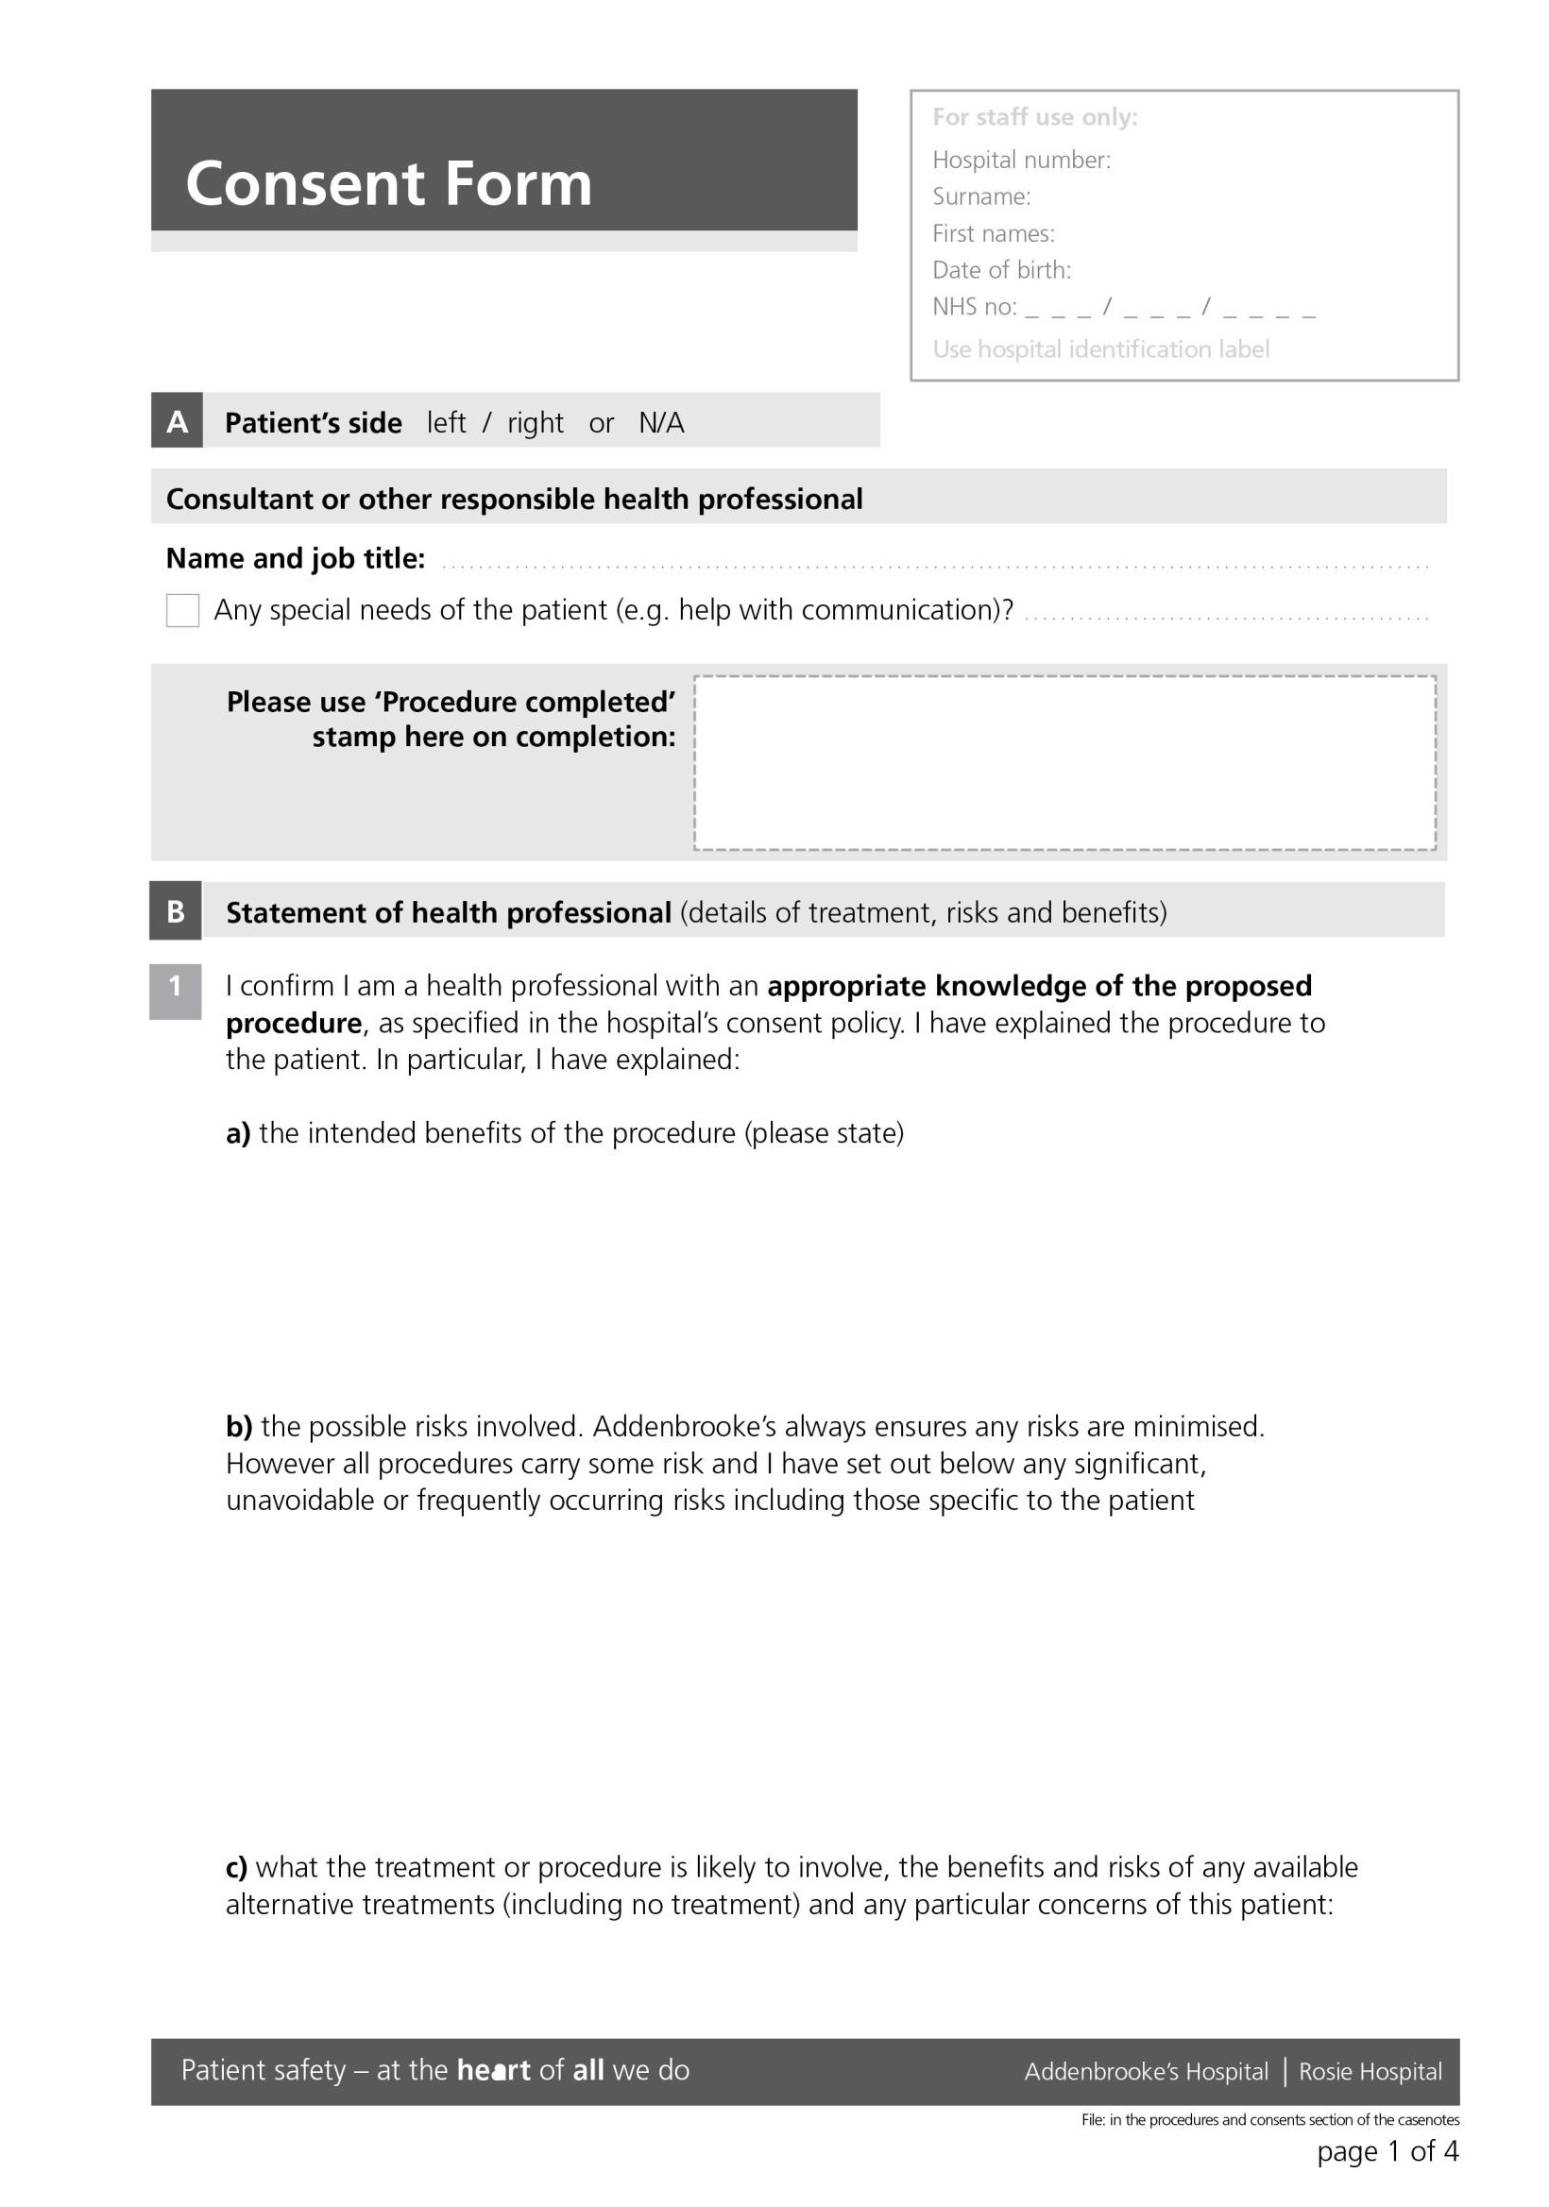
Patient
Information

Retropubic sling for stress urinary incontinence, CF450, V4, February 2020
Retropubic midurethral sling/transobturator midurethral sling for the surgical treatment of stress urinary incontinence

To cure or improve stress urinary incontinence. This will not improve symptoms of frequency and urgency.

Serious risks: Mesh erosion into the vagina or other organs like bladder or bowel. This may require further surgery to resolve the problem / damage to the bladder or the urethra / Injury to other organs such as bowel and major blood vessels has been reported / develop the need to pass water very often, or get little warning of needing to go to the toilet or have trouble getting to the toilet in time. This may respond to drug treatment/pain in the inner thigh at the site of the tape insertion (following transobturator tape).
Frequent risks: developing a clot due to bleeding in the area where the tape is placed. This will usually resolve in the few months following the procedure / develop a urinary tract infection after the procedure/problems with fully emptying the bladder, requiring catheterisation for a few days after surgery. It is very rare for this to be a long-term issue.

Midurethral sling for stress urinary Incontinence_V4_February 2020

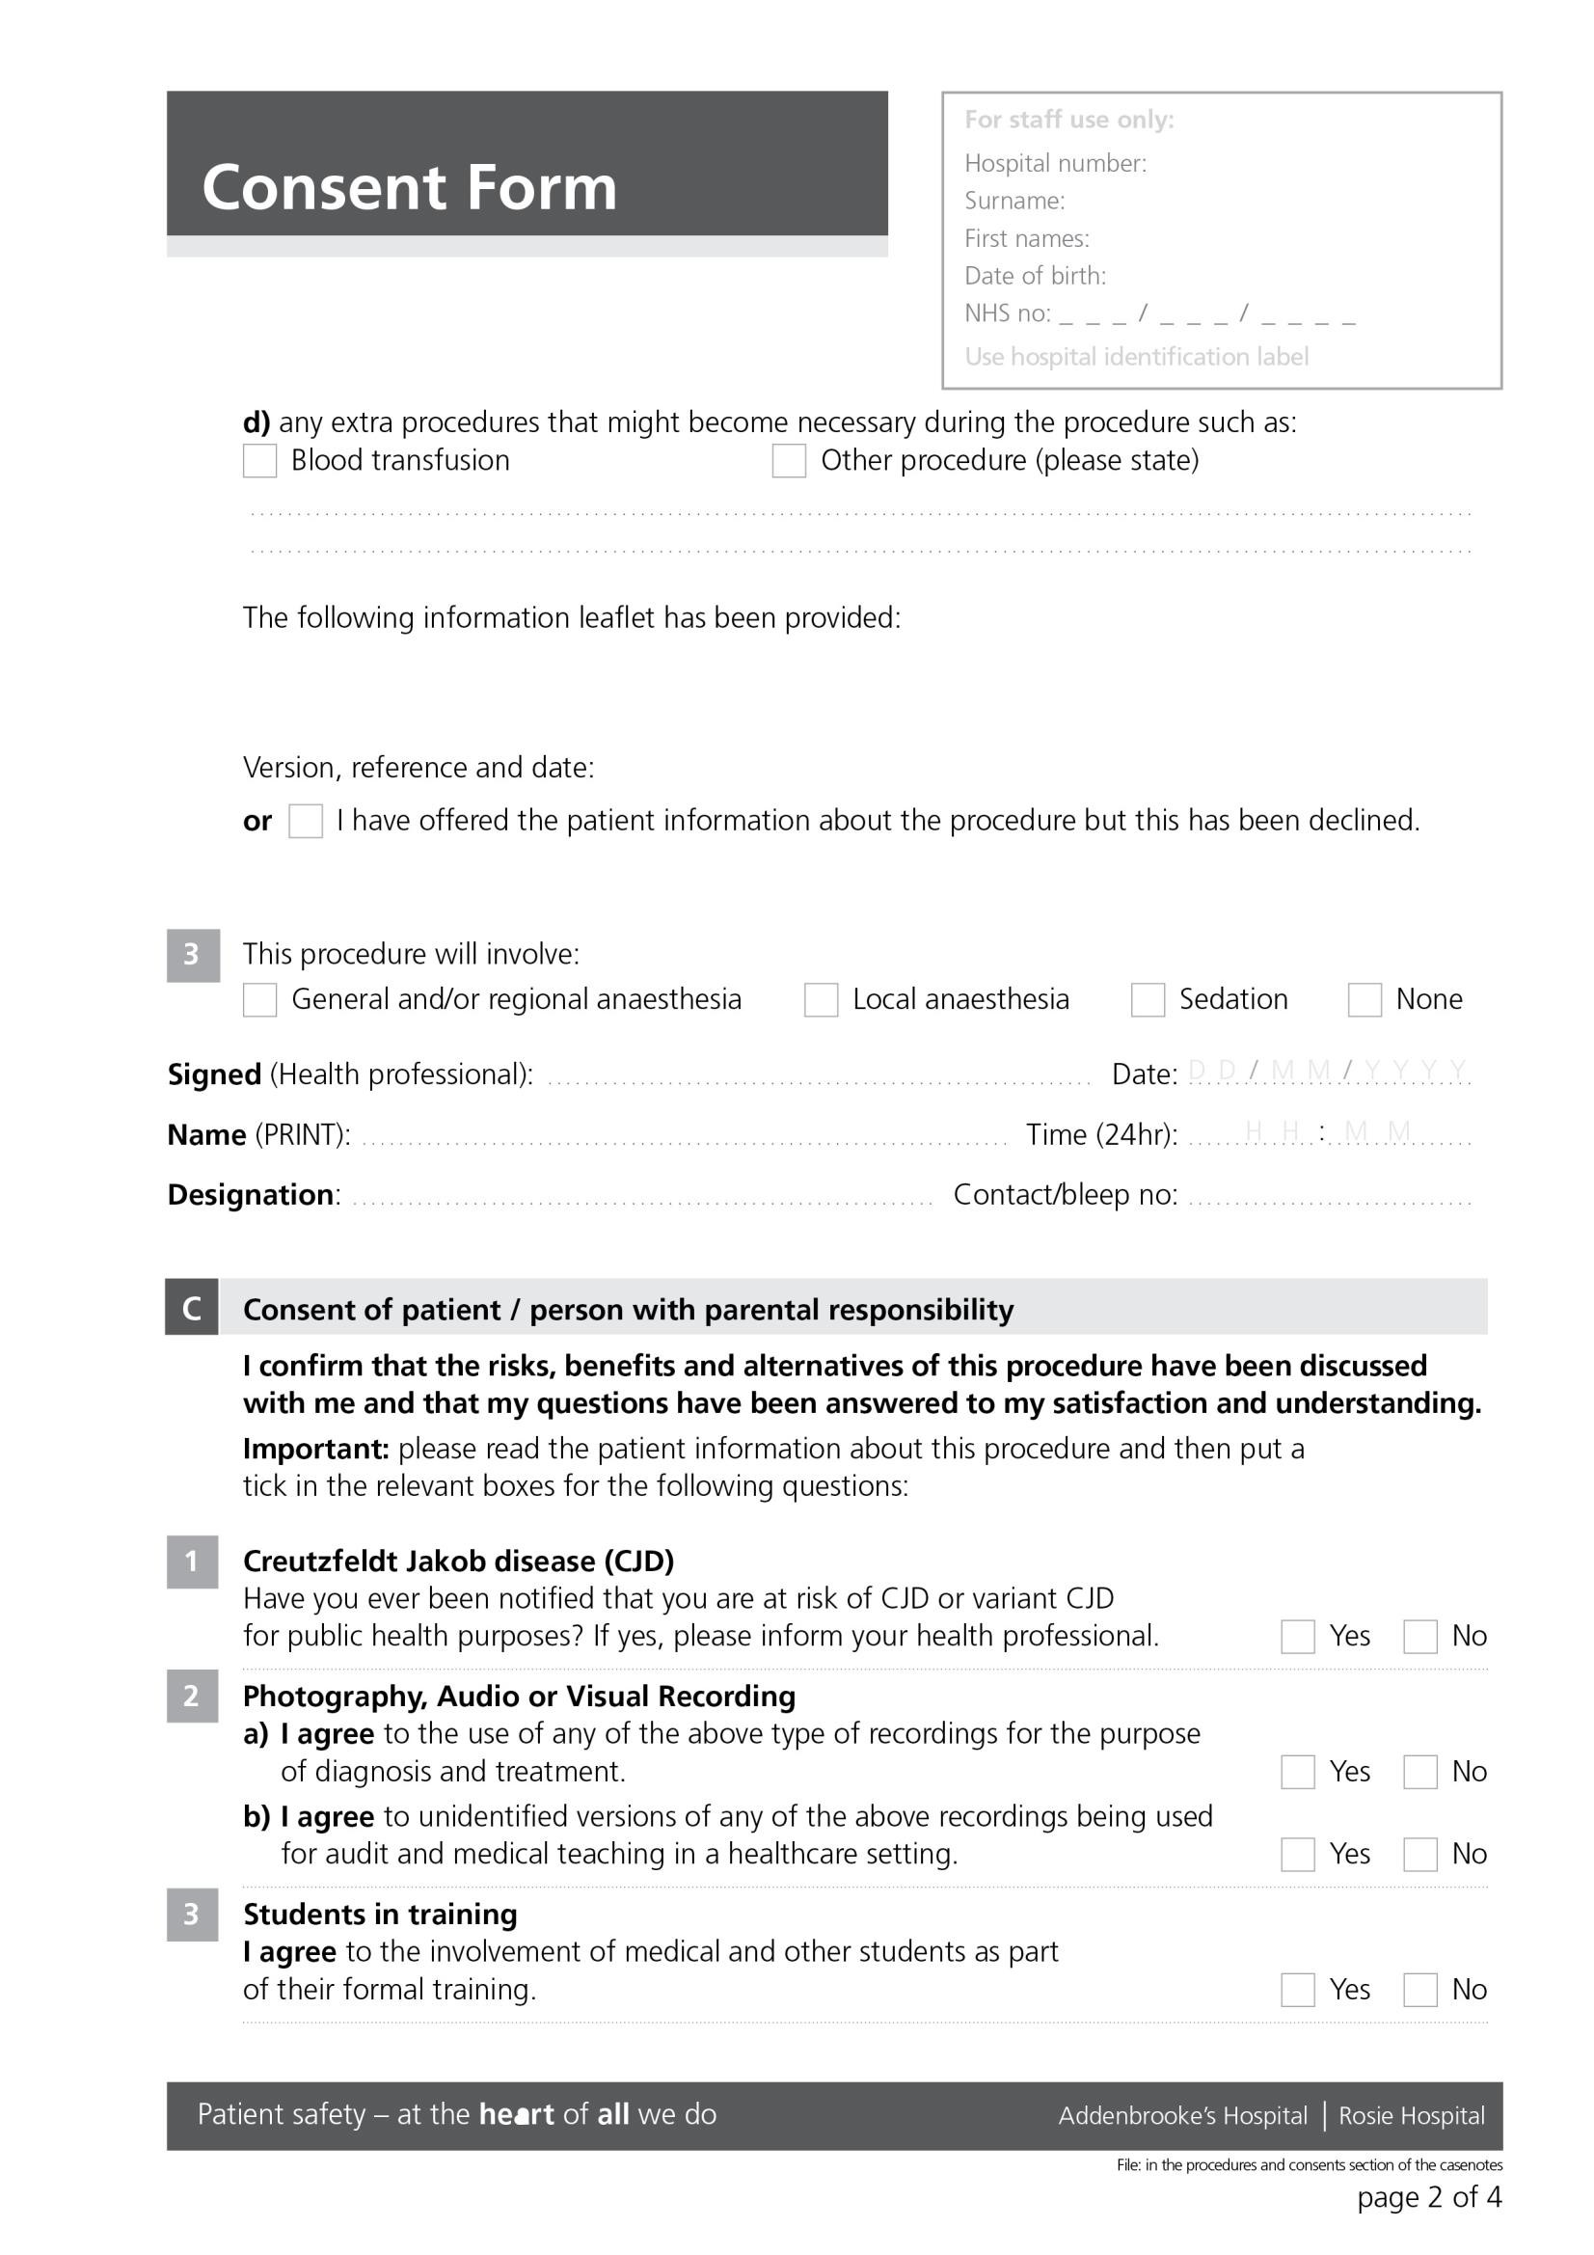
Patient
Information

Retropubic sling for stress urinary incontinence, CF450, V4, February 2020
Retropubic midurethral sling/transobturator midurethral sling for the surgical treatment of stress urinary incontinence

Retropubic midurethral sling/transobturator midurethral sling for the surgical treatment of stress
CF450 Version 4 January 2020

Midurethral sling for stress urinary Incontinence_V4_February 2020

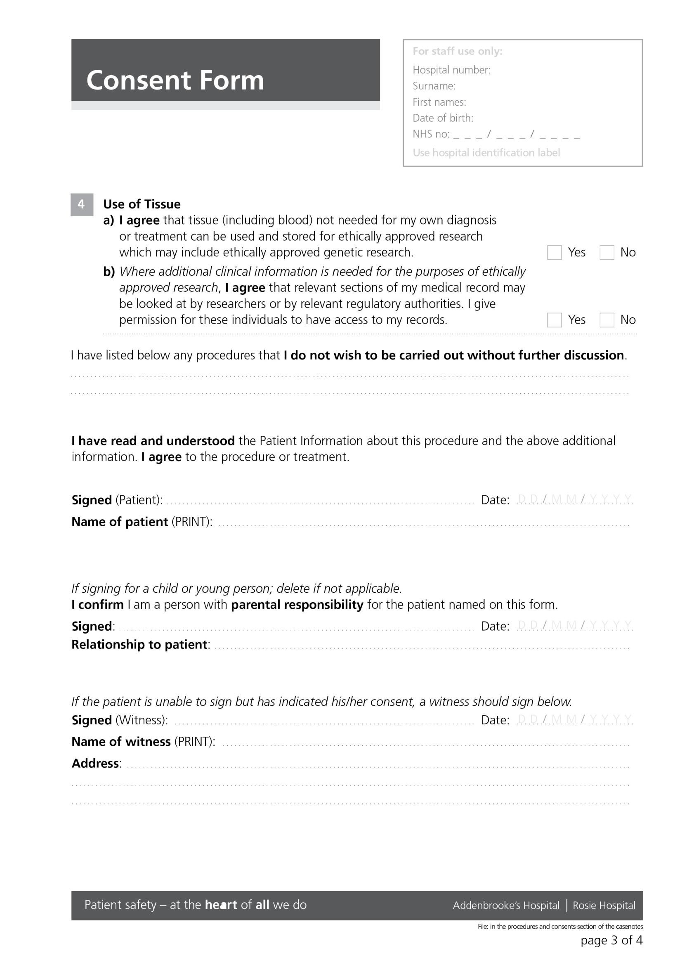

Retropubic midurethral sling/transobturator midurethral sling for the surgical treatment of stress urinary incontinence

Midurethral sling for stress urinary Incontinence_V4_February 2020

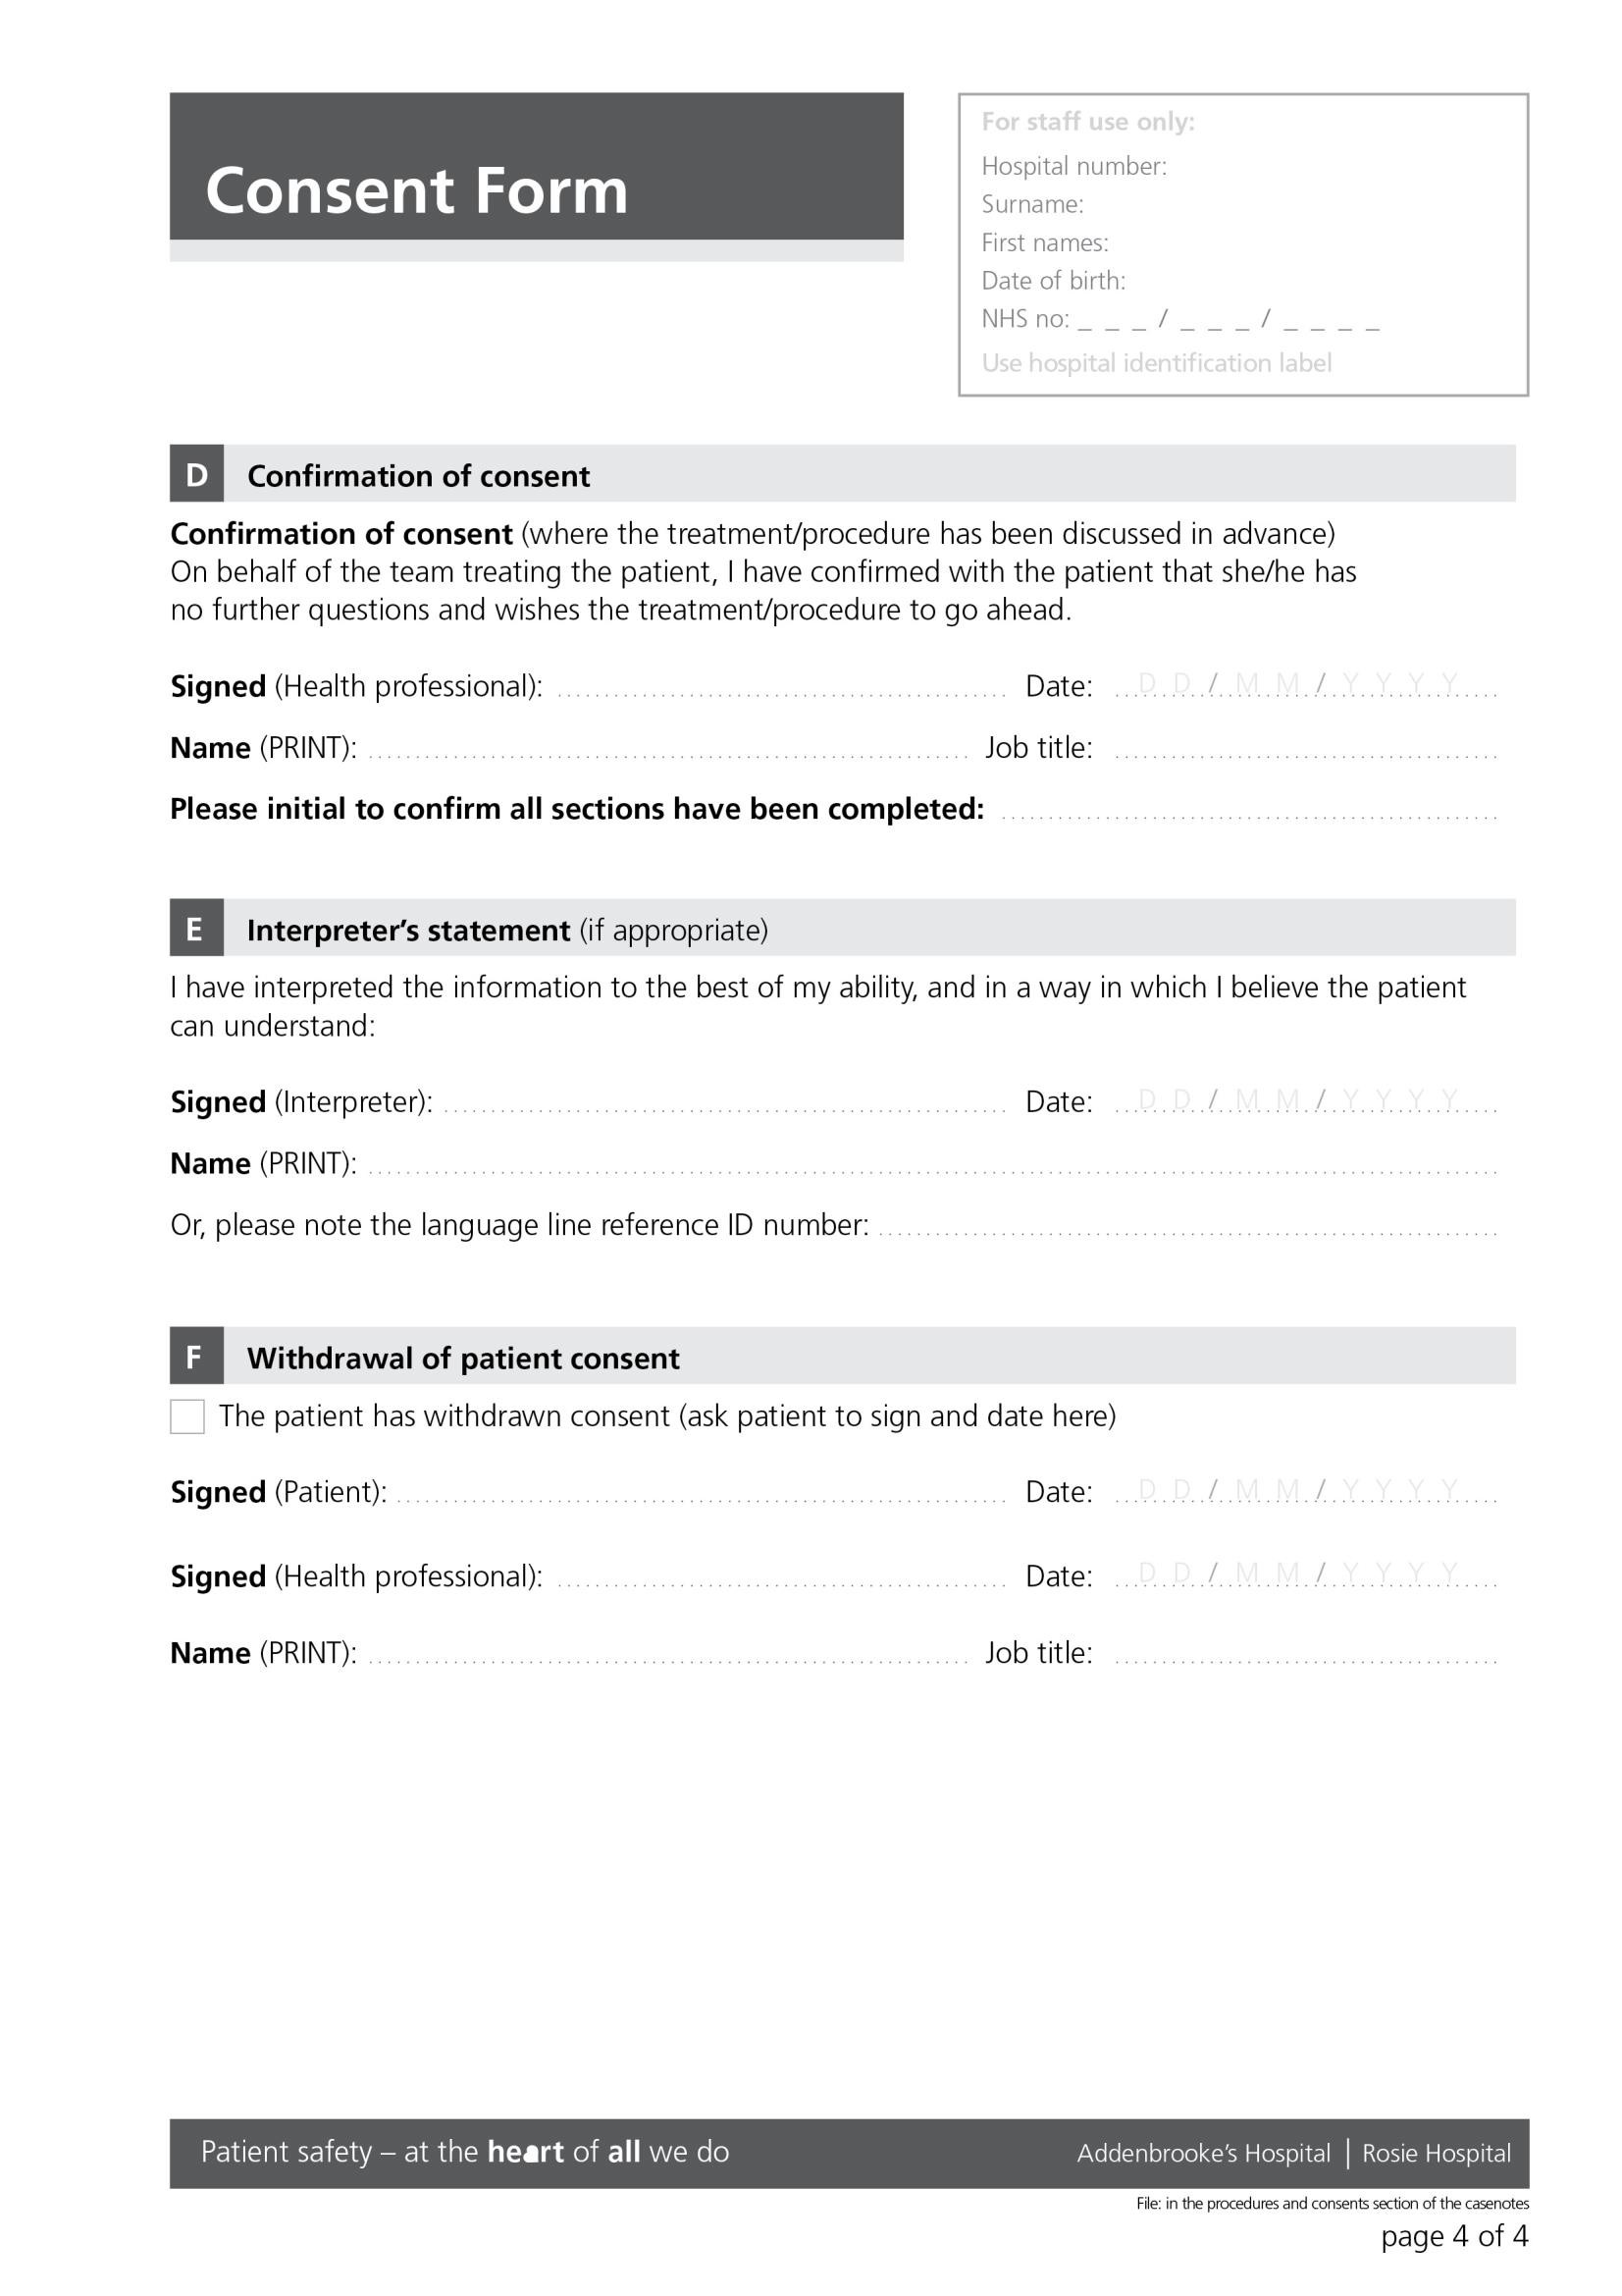

Retropubic midurethral sling/transobturator midurethral sling for the surgical treatment of stress urinary incontinence

Midurethral sling for stress urinary Incontinence_V4_February 2020

