SLEEP

STUDY

STORY

WARD F3

Step 1

For the first step we need to give you two bands to help
to look at how your tummy moves.

You will have one over your chest
and one over your tummy.

They have popper to keep each band together.

They are soft and stretchy and do not hurt.

We then attach your bands to your
Sleep Study Box.

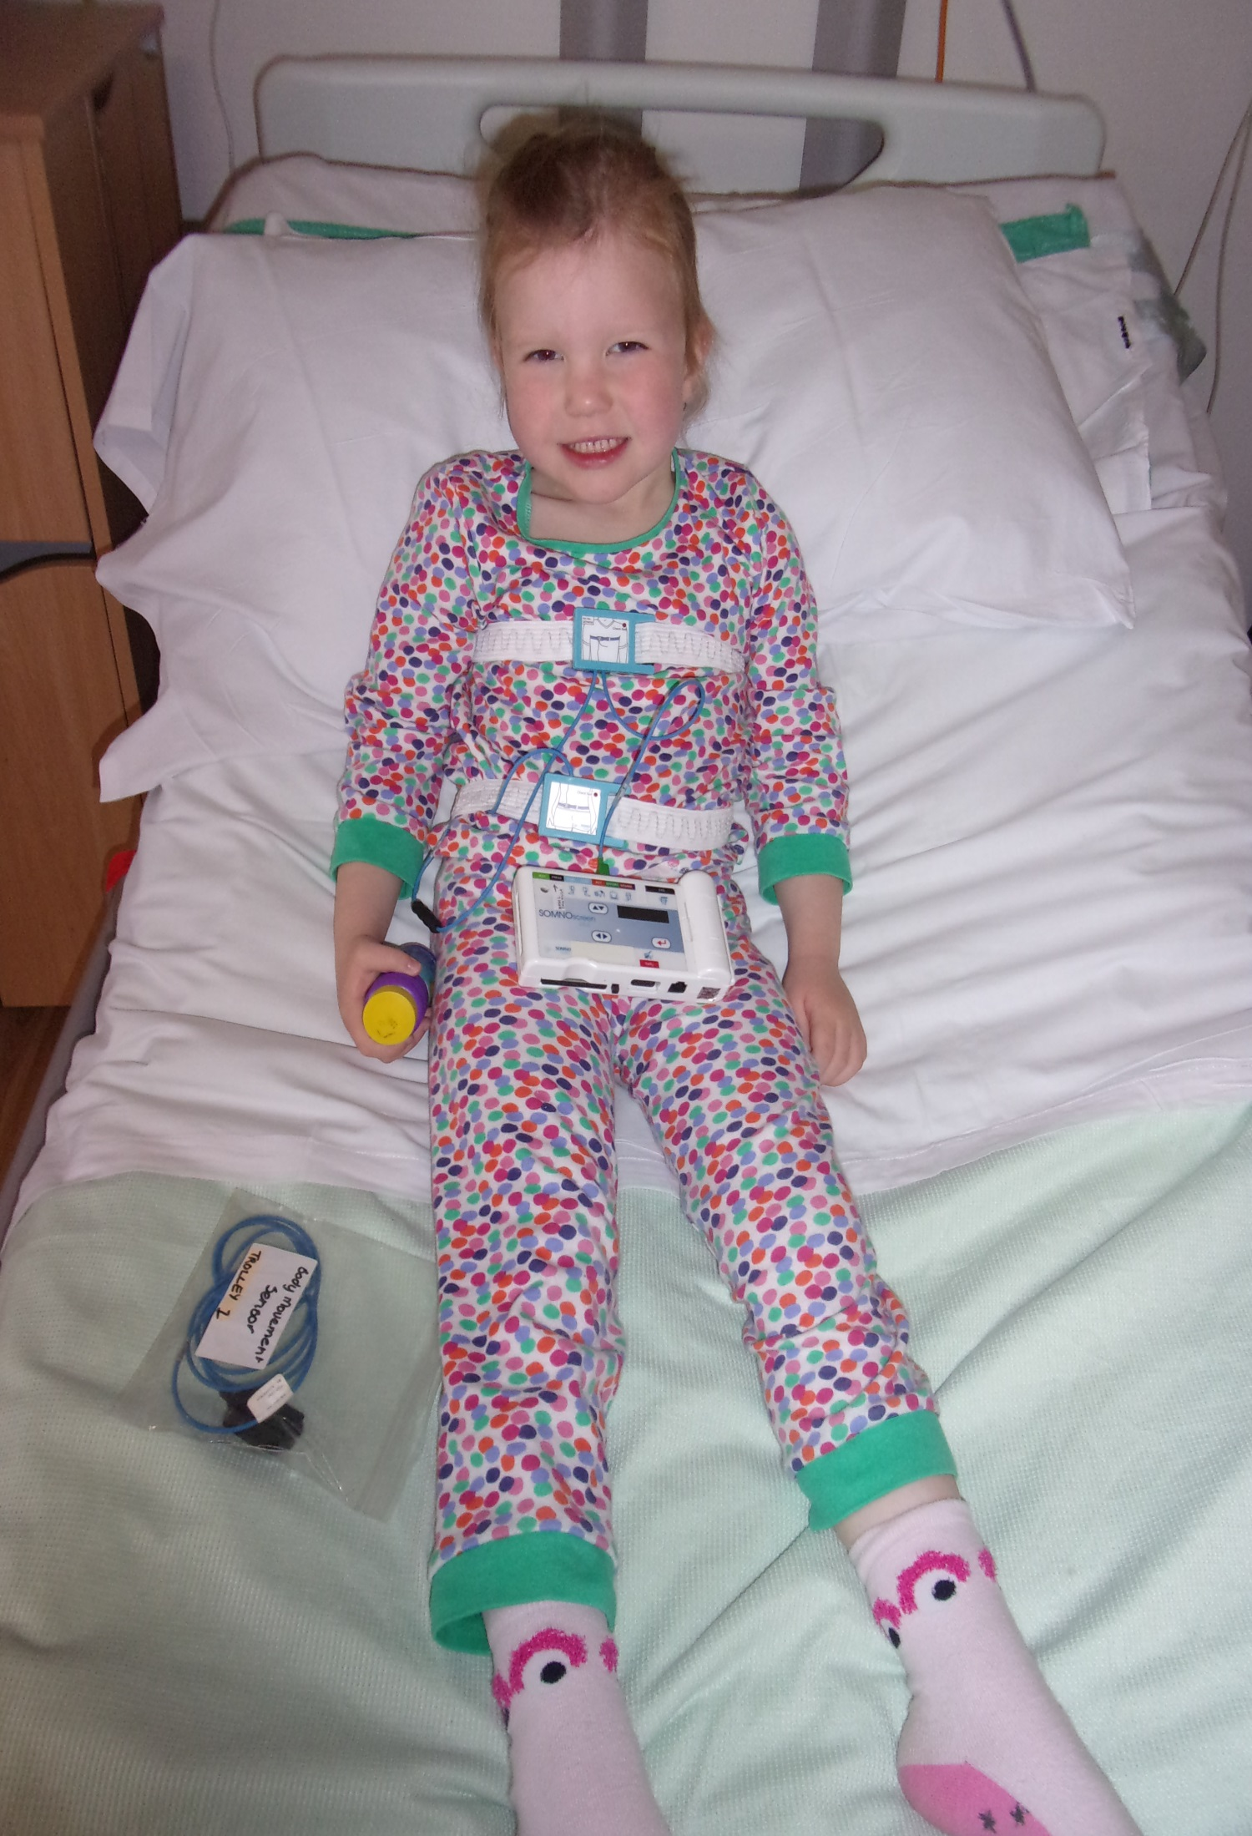

Step 2

We then need to attach a small black box with a
blue wire to your chest band.

The small black box does not touch you.

The black box tells us which way you are
lying on the bed.

We then attach the blue wire to your
Sleep Study Box.

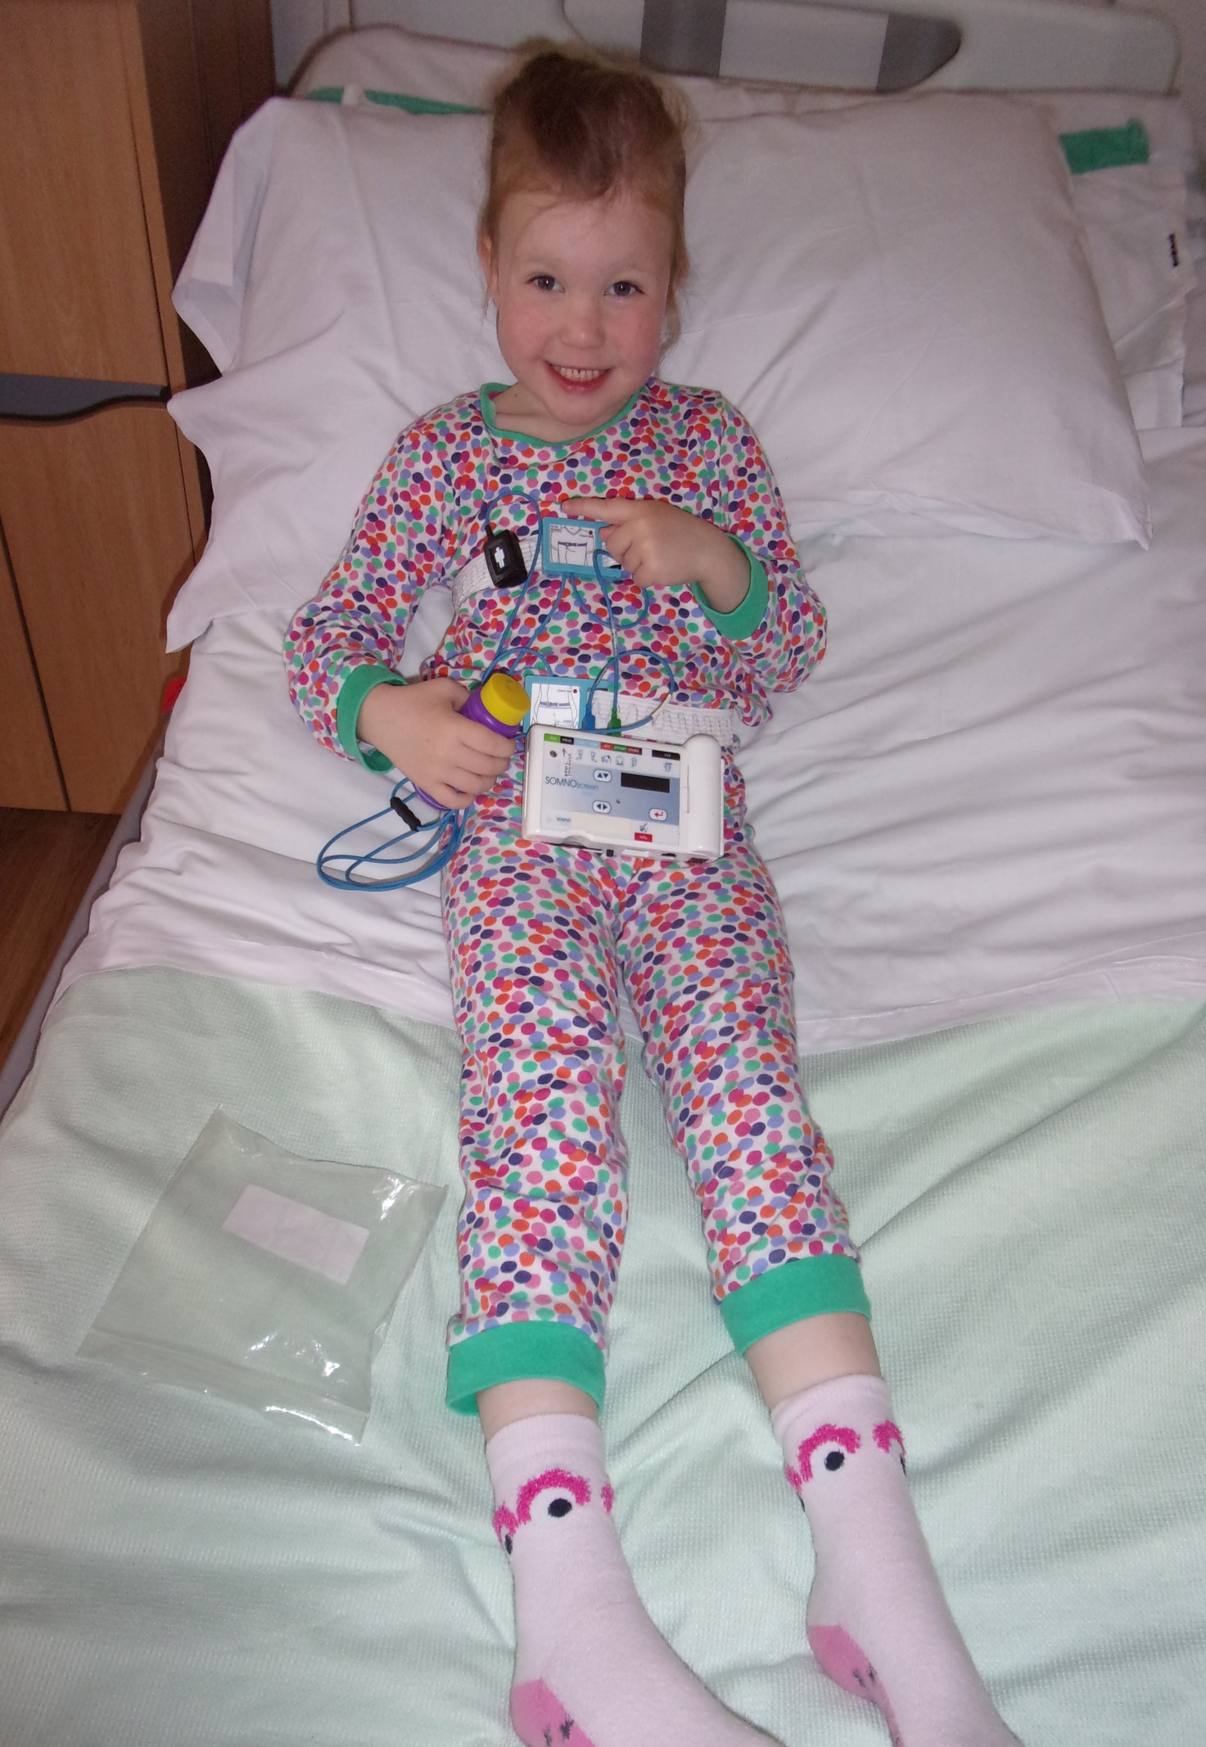

Step 3

While you are asleep we need to check your heart rate
and Oxygen in your body.

To help us do this, we need to put some small sticky tape
with a red light round your finger or toe.

This does not hurt and the wire will move with you
while you sleep.

We then attach the white wire to your
Sleep Study Box.

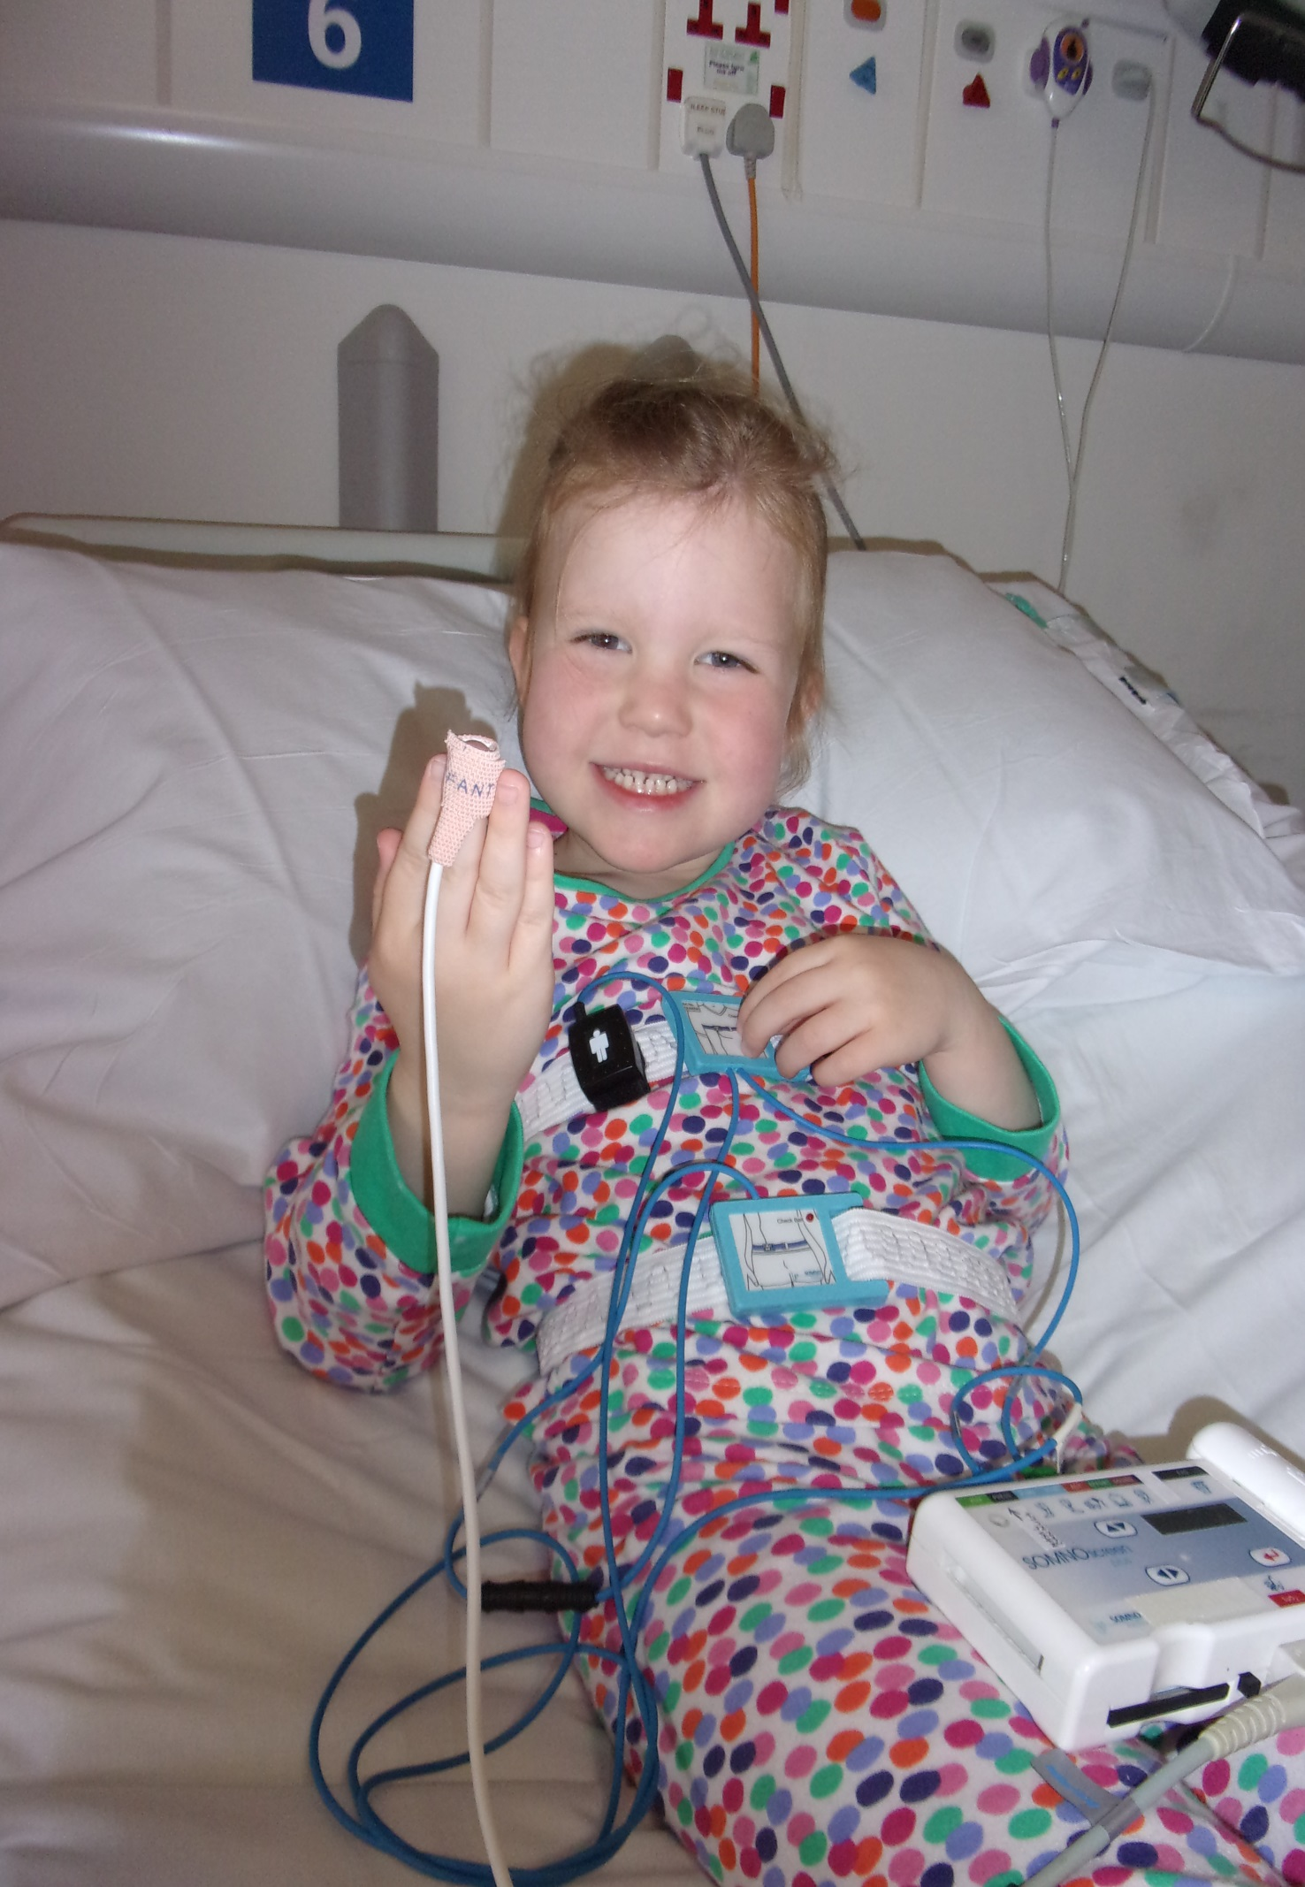

Step 4

While you are asleep we need to measure your breathing.

To help us do this, we need to put two little tubes
that rest just inside your nose.

These might feel a bit funny to begin with.

To help them stay on your nose we put them over
the top of your ears and put a small bit of special
sticky tape each side of your face.

They are attached to a bigger tube that is
connected to your Sleep Study Box.

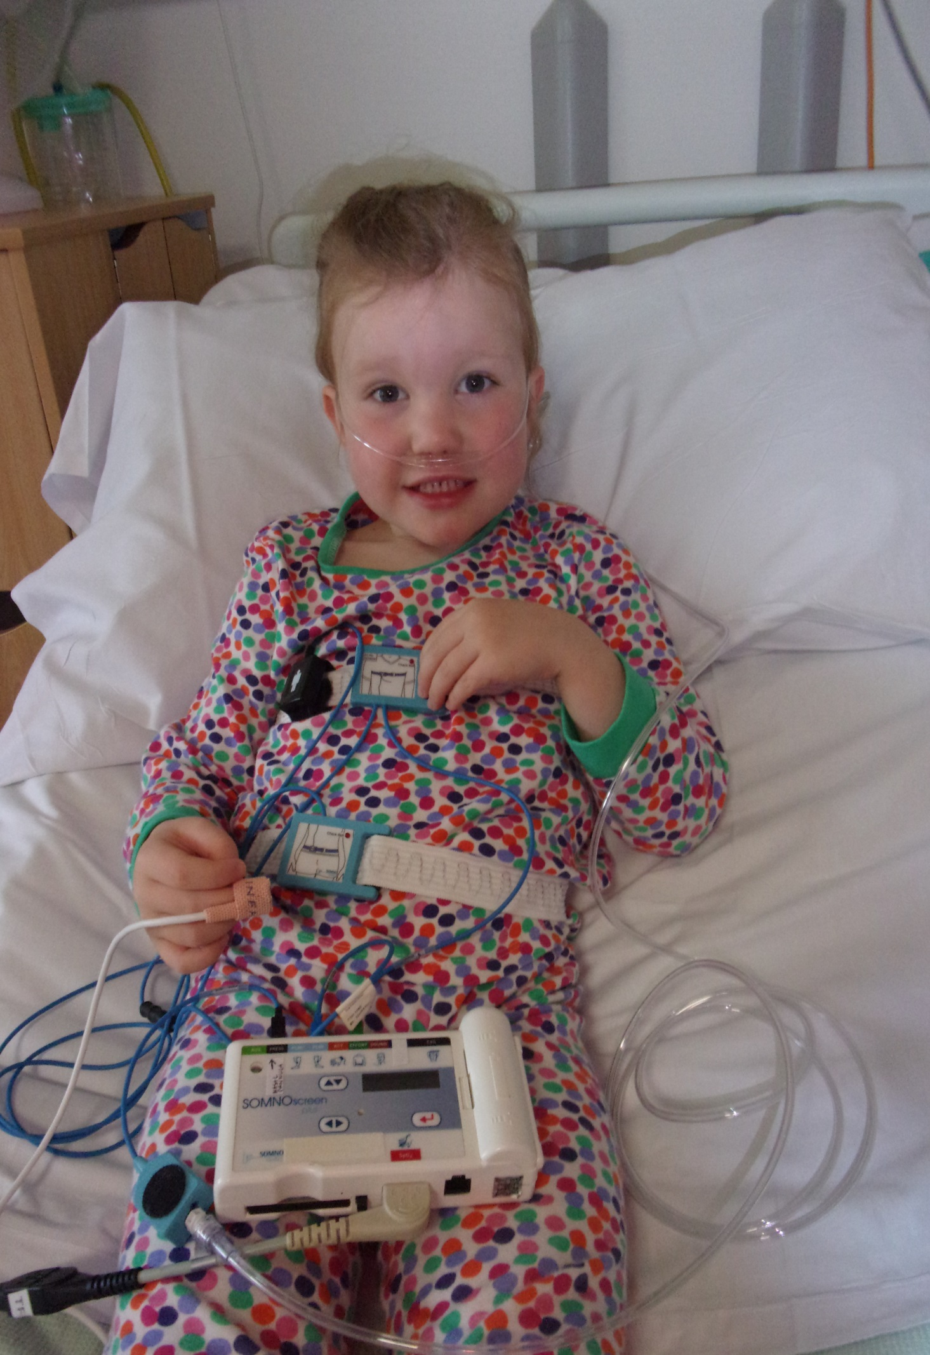

Step 5

The wires and tubes are ok while you sleep.

We need you to keep them on all night to
get the best results.

Night Night, Sleep Tight…..

