- To look for abnormalities within your bladder and/or urethra.

Common side effects (risk greater than 10 in 100)
- mild burning or stinging on passing urine, or visible blood in the urine, for a short period after the procedure which is helped by temporarily increasing your fluid intake

Occasional side effects (risk between 2 in 100 and 10 in 100)
- Infection of the bladder requiring treatment with antibiotics

Rare side effects (risk less than 2 in 100)
- Difficulty passing urine, particularly in men, necessitating temporary insertion of a urinary catheter
- Delayed bleeding requiring removal of blood clots or further surgery
- Injury to the urethra causing delayed scar formation (urethral stricture)

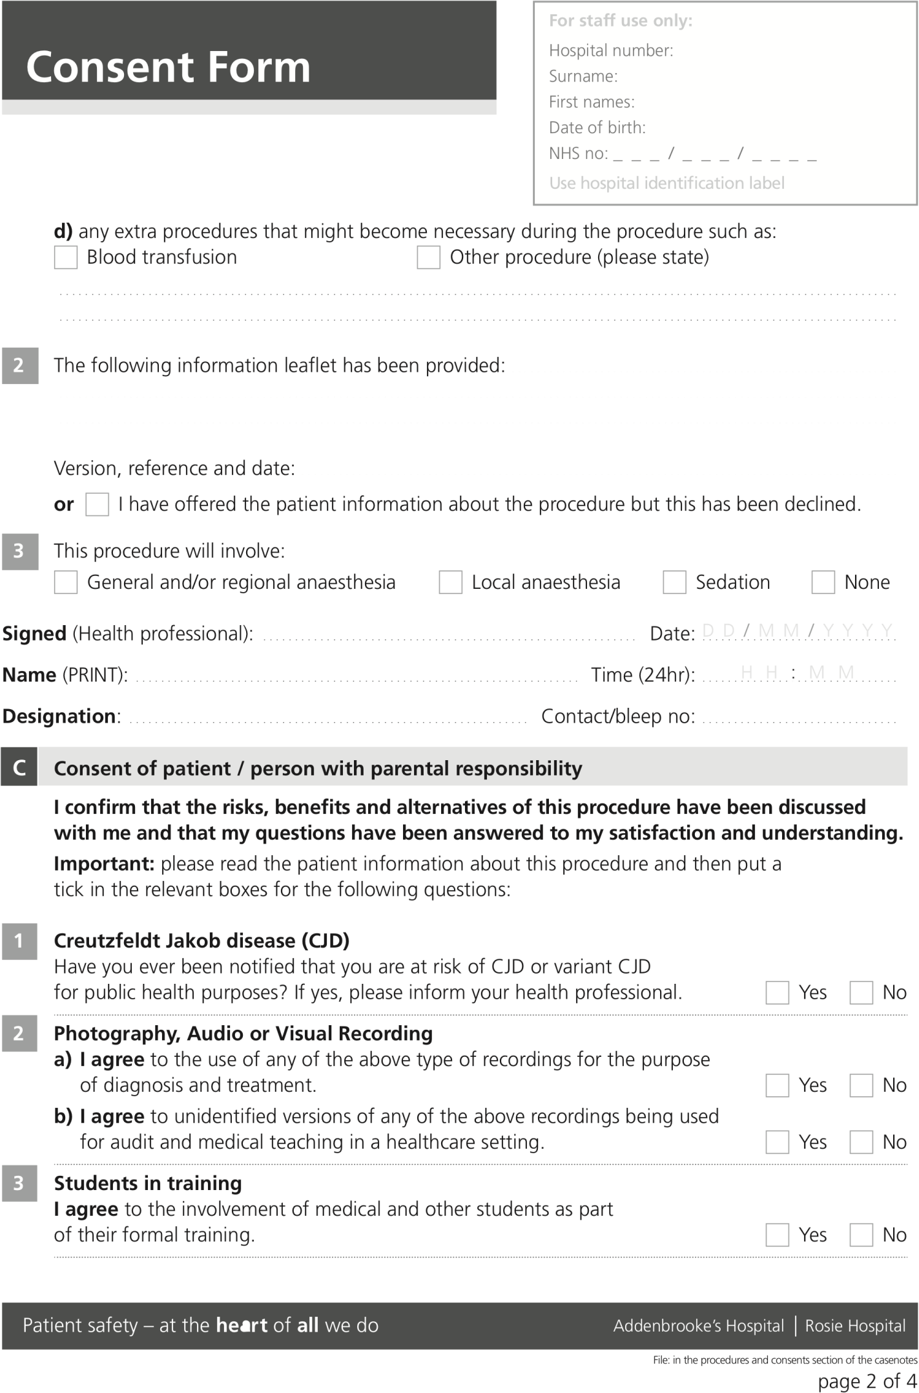

Flexible cystoscopy

Removal of JJ stent Need to take bladder biopsy

Flexible cystoscopy

CF310 Version 7, November 2020

