Easy Read

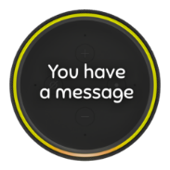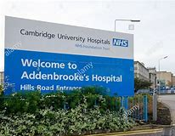 | A message from the medical director at Addenbrooke’s Hospital
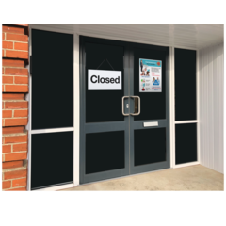  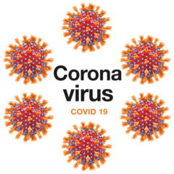 | Covid-19 pandemic has had a big impact on our work.  We have had to make lots of changes to our hospitals over the last few months. We are now very busy getting ready for the winter.
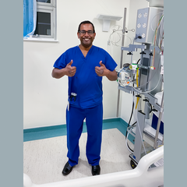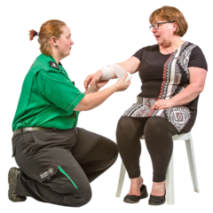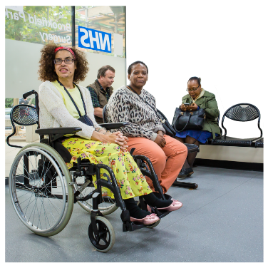 | We are still here for you. Either  - if you catch Covid-19 and need to come to hospital, but also  - to treat you and your family safely for your other health conditions.
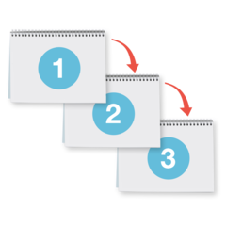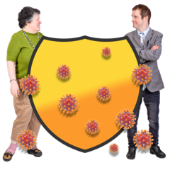 | We are taking steps to keep you safe in hospital, including:
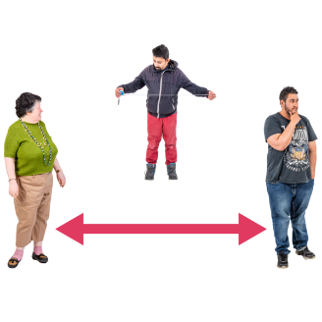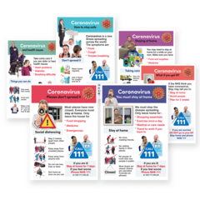 | - Social distancing  Our hospitals now have directions and instructions explaining how to keep a safe distance from others.
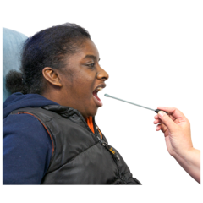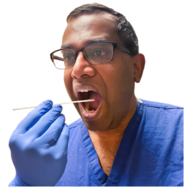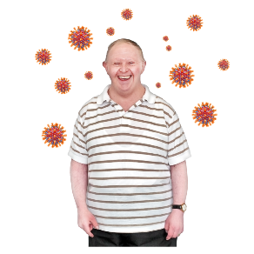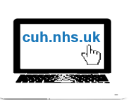 | - Testing  - The staff are regularly tested, even if they have no symptoms. The self-isolate if necessary.  - Patients who come to hospital are tested for Covid-19. Information about testing is on our website at cuh.nhs.uk.
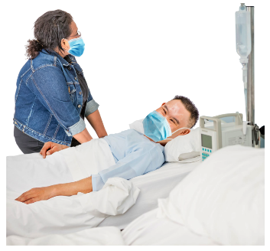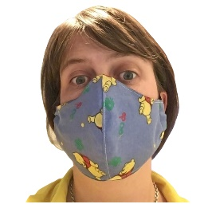  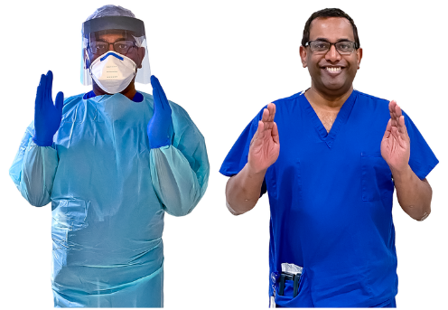 | - Protective equipment  - Patients, and visitors, are asked to wear a mask, or face covering, when walking around our hospitals. Full information about this is on our website at cuh.nhs.uk.  - Hospital staff wear protective equipment. This is designed to prevent the spread of infection. Staff in different areas might wear different PPE.
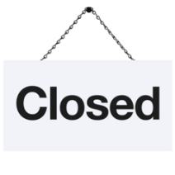  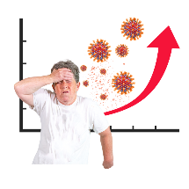 | Waiting times for treatment  During the Covid-19 lockdown, we had to make some difficult decisions about delaying some less urgent treatments. This included some operations/surgery.
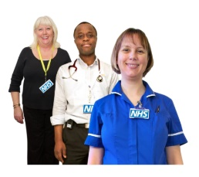  [Grab your reader’s attention with a great quote from the document or use this space to emphasize a key point. To place this text box anywhere on the page, just drag it.]  Open  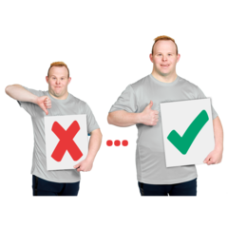 | Now most services are open. But some some are running more slowly and waiting times for treatment have increased.  We have a backlog of patients that we are working through as quickly as we can.
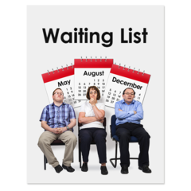 | If you are waiting for treatment you have not been forgotten. We know that everyone is on a waiting list for an important reason.  We understand the stress and anxiety that delays can cause.
We are managing our waiting lists so that patients who are most at risk are seen first.

If you are waiting, we will be assessing the risk of the delay to you.

Everybody who has waited longer than normal will get a letter. It will tell you what to do if you’re worried, or if you think your condition is getting worse.
Again, our website has more information.
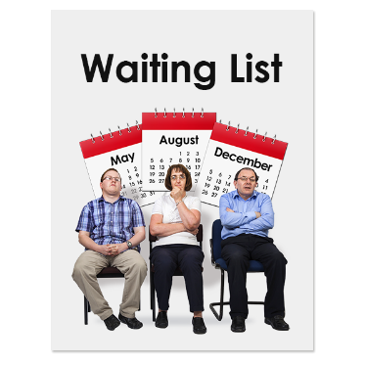 | Over the next few months we will get a better idea of the waiting times for people needing tests or treatment.  When you went on the waiting list you might have been given an idea of when you might have expected to be treated, and now you don’t know how long your wait might be. We know this is very frustrating and upsetting.
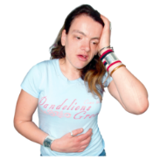  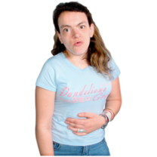  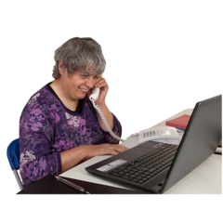  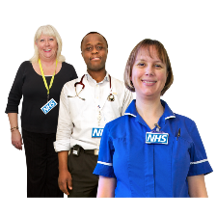 | But while you are waiting, if your health changes, or you become worried that you are getting worse it, is important that you contact your clinical team(who is this? Consultant, general dept??).  More information about how to do this is available on our website.
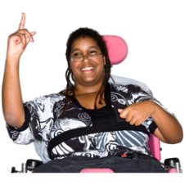  01223 216756  pals@addenbrookes.nhs.uk | Your questions and comments  If you have any questions or concerns get in touch with the Patient Advice and Liaison Service:  - on 01223 216756 or  - email pals@addenbrookes.nhs.uk.  Thank you so much for your patience. Your health matters a huge amount to us and we look forward to help you get better as soon as we can.
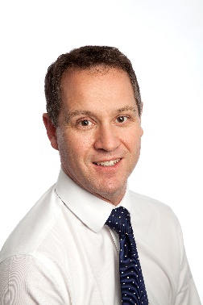 | With my very best wishes  Dr Ashley Shaw
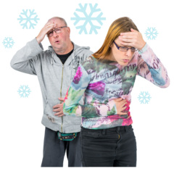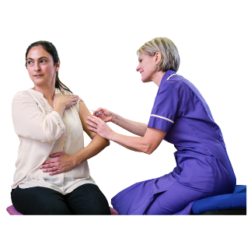 | PS - Do look after yourself and get a flu jab.  It will help our hospitals if we have less people who need to come to hospital with flu.

