Pre-Clinic Questionnaire
NAME: ……………………………………………
MRN: ……………………………………………..
Date of Appointment: …………………..

Welcome to the cleft team! We are looking forward to meeting with you today.
There are lots of different people in the cleft clinic. This is because it can be helpful for you to speak with different members of the team so that they can help you with anything you might be finding difficult and answer any questions that you might have. Sometimes, people can find it overwhelming having a lot of people in the room.
Is this something that bothers you? Yes No
If it is, we will see if there is anything we can do to help make this easier. Please let us know if you have any ideas as to what might help you in clinic today.
…………………………………………………………………………………………………………………………………………..
…………………………………………………………………………………………………………………………………………..
…………………………………………………………………………………………………………………………………………..
What is the key area you would like to consider in your clinic appointment today?
…………………………………………………………………………………………………………………………………………..
Do you have any concerns about or would you like to talk about any of the following areas:
Understanding my cleft School/Work Talking about my cleft
Hearing Surgery Friendships/Relationships
Talking/Speech Teeth Worries/Anxieties
Eating/Drinking/Feeding Appearance Emotional Well-being
Confidence Breathing Genetics
Do you have any specific questions you would like to ask the team today?
…………………………………………………………………………………………………………………………………………..
…………………………………………………………………………………………………………………………………………..
…………………………………………………………………………………………………………………………………………..
How worried are you about the areas you have selected? Please mark on the thermometer below to show how much these things are bothering you at the moment.
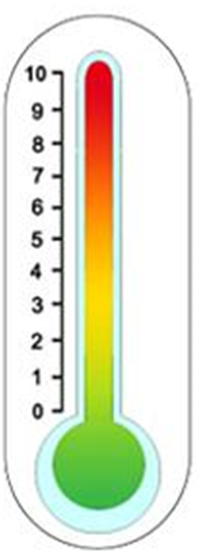
Please complete this form electronically and return to the Cleft team 1 week before your clinic appointment. Please use the email below:
Add-tr.cleftneteast@nhs.net
Not at all worried
It does not bother me at all
Very worried
It bothers me a lot

