Report to the Board of Directors: 11 October 2023

Agenda item | C8.1
Title | Annual Workforce Race Equality Standard (WRES) Report 2023
Sponsoring executive director | David Wherrett, Director of Workforce
Author(s) | Monica Jacot, Head of Equality Diversity and Inclusion
Purpose | To receive the annual WRES Report 2023 and action plan.
Previously considered by | Workforce and Education Committee, 20 September 2023

Executive Summary
The paper provides an annual update in relation to:
- The Trust’s 2023 Workforce Race Equality Standard (WRES) data set (submitted in May 2023) and new data sets the Bank WRES and Medical WRES.
- The CUH race disparity ratio benchmarked position as advised by the NHS England WRES team.
- A WRES action plan progress report.
- Proposed actions for revision to the WRES action plan. This includes development of an Antiracism policy that aligns with our pledges under the Unison Anti-racism Charter signed by the Director of Workforce on behalf of the Trust in 2022. This incorporates high impact actions required under the new NHS EDI Improvement Plan published June 2023.
- The Board is asked to note that the WRES position set out in this paper, sits alongside the Trust’s overarching commitment to workforce inclusion across the range of protected characteristics (see Appendix 1).

Related Trust objectives | Improving patient care;  Supporting our staff
Risk and Assurance | The report provides assurance on progress against the WRES.
Related Assurance Framework Entries | BAF ref: 008
How does this report affect Sustainability? | n/a
Does this report reference the Trust's values of “Together: safe, kind and excellent”? | Yes EIA – this paper, proposed anti-racism policy and ongoing action plans have a positive impact for black and minority ethnic staff and has been coproduced with the REACH staff network and Staff Side Secretary.

Action required by the Board of Directors
The Board of Directors is asked to:

- Note and discuss the WRES data results findings.
- Note action taken over the last 12 months.
- Note and discuss the proposed antiracism policy for CUH to become an antiracist organisation, areas of focus and actions for the refreshed WRES action plan.
- Ensure personal information on ESR is updated including ethnicity.
- Consider personal actions, and objectives to ensure commitment and accountability to tackle racism, progress race equality, and inclusion.

Cambridge University Hospitals NHS Foundation Trust
11 October 2023
Board of Directors
Annual Workforce Race Equality Standard (WRES) Report 2023
David Wherrett, Director of Workforce
Claire London, Director of Culture, Leadership and Learning
Monica Jacot, Head of Equality, Diversity and Inclusion

- Introduction / Background
  - This paper provides the Board with the 2023 WRES data set for CUH (submitted in May 2023) with a summary of actions taken in the past year. A refreshed WRES action plan and anti-racism policy is proposed that aligns with the Unison Anti-racism charter the Trust signed in 2022 and incorporates the high impact actions for Trusts to implement as set out in the recent NHS Equality Diversity and Inclusion Improvement plan.
  - The WRES was introduced in April 2015. The NHS England WRES briefing for Boards states that NHS workforce race equality delivers better care, outcomes and performance. Research and evidence such as that of Prof. Michael West and Prof. Jeremy Dawson has found that less favourable treatment of Black and minority ethnic (BME) staff in the NHS, through poorer experience or opportunities, has significant impact on the efficient and effective running of the NHS and adversely impacts the quality of care received by patients. Prof. West et al assert: “The greater the proportion of staff from a Black or minority ethnic background who report experiencing discrimination at work in the previous 12 months, the lower the levels of patient satisfaction. The experience of BME staff is a very good barometer of the climate of respect and care for all within NHS Trusts”
  - The Board is reminded that, in its simplest form, the WRES offers NHS organisations the framework to understand their workforce race equality performance. This includes the degree of BME staff representation at senior management and board level. The WRES indicators highlight differences between the experience and treatment of white staff and BME staff in their organisations. As such, it is intended to help all NHS organisations focus on where they are right now with this work, where they need to be, and to plan and deliver improvements.
  - In presenting this report, it should be highlighted that all leaders and all members of the workforce have a responsibility and a role to play. Furthermore, leaders and the workforce are accountable for tackling racism and discrimination and promoting inclusion.
  - The CUH WRES plan and anti-racism strategy is informed by:
Unison Eastern Anti-racism Charter agreed by the management staff forum and signed by the Director of workforce on behalf of the Trust in 2022. The charter outlines various pledges under the themes of leadership, process and audit.
NHS England East of England Antiracism strategy 2021 to address three areas of focus: leadership and management; career progression and talent management as well as tackling racial harassment and abuse.
NHS Equality Diversity and Improvement plan published June 2023. This plan prioritises the following six high impact actions to address the widely known intersectional impacts of discrimination and bias. See appendix 5.
- 2023 WRES Data set (see spreadsheet attached appendix 2)
  - The WRES indicators for the Trust’s 9th WRES data report to NHS England were submitted in May 2023. In summary the Trust has:
- Improved in two of the nine indicators in the last year namely:
WRES Indicator 1, Staff profile by pay band. There has been appointments of BME staff into more senior non-clinical roles. However, it is important to note that BME staff in clinical roles are still less likely to be in band 6 and above.
WRES Indicator 2, Appointment rate after shortlisting. White staff now 1.58 x more likely than BME staff to be appointed (compared to 1.754 x more likely in the previous year)
- Maintained our position for 3 indicators:
WRES Indicator 3, White staff more likely to enter formal disciplinary investigation. BME 0.52 less likely than White staff. This is the same ratio as last year’s data set submission in 2022.
WRES indicator 4, there is no difference, there is equity between White and BME staff accessing non mandatory training. White staff are 0.98x as likely compared to BME staff to access non-mandatory training.
WRES indicator 9 Board representation – 16% of our Board 2 non-executive directors are BME. Our model employer target set by NHS England based on our Trust overall BME staff profile is 1 in 4 BME staff representation at all levels in the organisation. None of our Executive Directors is BME. CUH is ranked in the worst, lowest 25% quartile for this metric nationally.
The Trust has deteriorated in the 4 WRES indicators (5-8) related to the NHS staff survey questions:
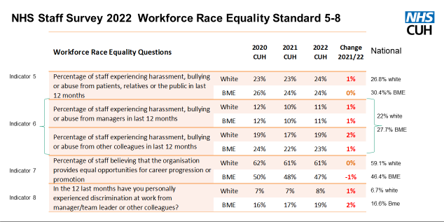
2.2 The results for the indicators 1-4 are set out in more detail below.
2.2.1 WRES indicator 1

As at 31 March 2023, 30% of the workforce are BME which is an increase from 28.6% at 2022. The ethnic origin is not known on the electronic staff record (ESR) for 4.1% of our staff (an improvement from 4.7% in 2022). The numbers of BME staff have increased in bands 6, 7 and 8 particularly in non-clinical roles. 10% of our total BME staff are in non-clinical posts. BME staff are predominantly in clinical roles and under- represented in bands 6 and above. 40% of CUH medical staff are from BME groups but most are in training and career grade posts and underrepresented in consultant posts with just 8% of consultant posts filled by BME staff (refer to appendix 2 for staff profile and divisional breakdown.)

2.2.2 WRES indicator 2

White candidates are 1.58x more likely to appointed after shortlisting than BME candidates (this is an improvement on the previous year when White candidates were 1.74x more likely to be appointed).
There is a difference between non-medical and medical recruitment chances for BME candidates being appointed. Non-medical staff recruitment data shows white candidates were 1.56x more likely to be appointed after shortlisting compared to White shortlisted candidates for medical posts who were 2.18x more likely than BME candidates to be appointed.
The medical recruitment data does not include doctors in training on rotation which are recruited by the deanery.

2.2.3 WRES indicator 3

This indicator has maintained improved position on last year. BME staff are 0.52 x less likely than white staff to enter the formal disciplinary investigation process. This is a reflection of a number of factors.
There are a small total number of cases entering the formal disciplinary process overall, which are either prevented from entering the formal stage at the pre-action review (PAR) triage stage sometimes involving a cultural ambassador if BME staff are involved.
The employee relations team are also querying allegations and preventing cases entering the PAR stage. A presentation by the Head of Employee relations of their analysis of all cases to the WRES implementation group for a deep dive discussion in June 2023, however identified the disproportionate number of initial allegations raised against BME staff overall and the concern that some line managers are using other formal people management processes such as the performance management procedure disproportionately and inappropriately for BME staff.

2.2.4 WRES indicator 4

White staff are 0.98 x more likely than BME staff to access non- mandatory training; there is equity. However, accessing non-mandatory training is not sufficient by itself for career progression for BME staff; the deficit model as it is referred, must not be relied upon by the organisation to improve career progression for BME colleague. The continuation of positive action programmes, de-biasing recruitment, and structural changes to deal with systemic bias is needed.

2.3 New data sets Bank WRES and Medical WRES
In addition to the normal WRES Indicators 1-9 data set, the Trust has submitted two additional new data sets to NHS England in June 2023: the Bank WRES and the Medical WRES with support from workforce information, bank services and medical staffing.
These data sets were launched in March by NHSE and although not mandatory there was strong encouragement to submit this data. We have used the opportunity to test the collection process this year in readiness for next year’s submission and query these data sets technical guidance too with the NHS England data analysis team.

Bank WRES
The Bank WRES indicators compare experience of BME and white bank only workers. Indicator 1 is the numbers of BME and white bank workers employed by pay band, clinical and non-clinical. Indicator 2 is the numbers of bank workers dismissed.
Other Bank WRES indicators relate to responses to NHS staff survey 2022, data that our bank workers took part in. Results will be shared by NHS England EDI team later this year.
Medical WRES (MRES)
There are eleven MWRES indicators overall and some of the indicators have subsections. The indicators comparing experience for BME and white medical staff present data on
- medical workforce ethnicity composition,
- medical career progression,
- rewards and Staff feedback,
- experience and treatment of medical staff.
In February 2024 NHS England will publish results and an analysis report on our Medical WRES results and the national overall position.
- National position NHS England WRES data analysis of CUH position and race disparity ratios
In March 2023 we received NHS England WRES team’s second detailed analysis report of the CUH data that was submitted in 2022. This gave us our ranking for all indicators and the national team have calculated our Trust’s race disparity ratio looking at all our WRES data submitted from 2017 (see table below).
The race disparity ratio compares the progression of white staff through the organisation with BME staff through the organisation. If the race disparity ratio is greater than “1.0” then this means that progression favours white staff.
As at March 2022, the race disparity ratios for non-clinical staff on Agenda for Change (AfC) pay bands shows that for lower to middle bands CUH performs 0.76 better than 55% of Trusts. In middle to upper bands, CUH has a race disparity ratio of 2:16 which is worse than 76% of Trusts. In lower to upper CUH has a race disparity ratio of 1.63 which is better than 55% of Trusts.
For clinical staff on AfC pay bands (excluding medical staff) the race disparity ratio the position is worse.
Lower to middle pay bands data shows CUH has a race disparity ratio of 2.75, which is a worse position than 86% of Trusts.
In middle to upper pay bands, CUH has a race disparity ratio of 1.54, which puts us at a worse position than 68% of Trusts.
For lower to upper pay bands, our race disparity ration is 5.42 which is worse than 84% of Trusts.
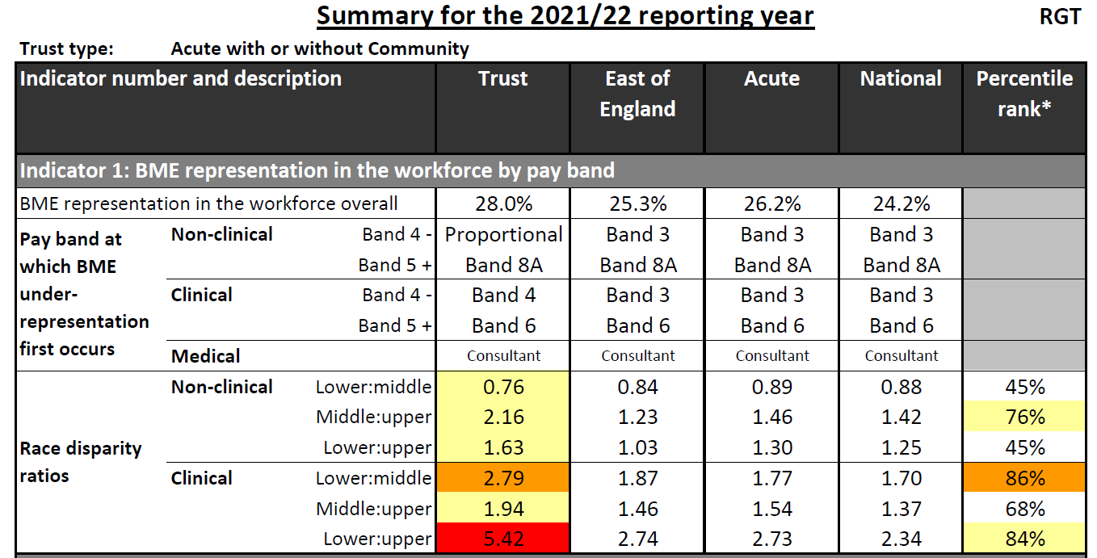
As with last year’s data analysis report received from NHS England (2022) the national team state the three high priority areas for improvement remain in these areas.
- WRES Action 2022/23 plan update - The past 12 months
The three key areas of focus for the WRES action plan in 2022/23 have been:
- Inclusive leadership and management including proportionate representation in senior roles and decision making, in addition to educating our leaders and supporting their commitment to anti-racism.
- Equitable and inclusive talent management and clinical career progression.
- Protection of staff from racial harassment and abuse from patients/public and colleagues.
The WRES implementation group chaired by the Director of Culture Leadership and Learning, meets bi-monthly, with action plan owners and REACH network members, to review the progress of the WRES action plan.
4.1 Priority 1 - Inclusive leadership and management
4.1.1 Actions are outlined below:
- More Diversity Inclusion Panellists (DIP’s) have been recruited. Currently we have 62 diversity inclusion panellists trained to be involved in interview process for all band 7 positions.
- A debiasing recruitment task and finish group has been set up and is chaired by the Director of Culture Leadership and Learning. The focus being to examine and debiase the whole recruitment and on-boarding process. In addition, to implement evidence based best practice and the NHS East of England No Tick Boxes guidance and it’s supporting practitioner guidance. Progress to date includes adverts, job descriptions and person specifications reviewed for inclusive language. Use of a gender decoder, reduction of essential criteria and removal of desirable but without impacting pay banding.
- We published our first Ethnicity pay gap report in March 2023.
- New WRES divisional dashboard has been created by the workforce information project lead. This dashboard provides the ability to drill down Trust WRES data by division and corporate function, by staff in post and WRES staff survey metrics. This has been shared with divisional heads of workforce to encourage engagement and ownership of this work and help identify hot spots for divisional level action.
- The Trust’s exit survey has been reviewed with input from WRES implementation group and REACH staff network members.
- The REACH staff network (previously the BAME staff network) was relaunched in October 2022. REACH stands for race equality and cultural heritage. This relaunch took place with a new logo and a day of guest speakers. Monthly meetings have been set up both virtually, quarterly and face to face to improve access. The REACH network organised a successful month of events and talks to mark Black History Month.
- Arrangements to support all staff networks to thrive are in place. All staff network chairs are now in receipts of protected time of 15 hours per month and an honorarium payment has been introduced. This is £5k p.a. for the chair and £2.5k p.a. for co-chairs.
- Education on racism and allyship; The BRAP Be Curious about Race programme for leaders highlighted in the WRES action plan was being scoped and developed with Head of Leadership and OD and Head EDI. (Note: In May 2023 the new interim Director of EDI proposed implementation of a possible alternative allyship programme, the pilot taster sessions for CUH leaders to participate in have been planned to see if this is suitable for roll out in CUH.
- As identified in our WRES action plan, funding for the second cohort of the Reverse Mentoring (RM) programme for executives and senior leaders in the divisional triumvirates (Divisional Directors, ADOs and Divisional Heads of Nursing) was applied for and granted by the Funded Learning Approval group (FLAG) and is scheduled to start in October 2023.
4.2 Priority area 2 - Equitable and inclusive talent management and clinical career progression
4.2.1 Actions are outlined below:
- The Funded Learning Approval group (FLAG) group now has quarterly equality monitoring reports to monitor applications to FLAG.
- Two successful career progression webinars held for BME nurses and midwives. This has been organised by REACH network members, Cultural Ambassador (CA) and the RCN learning representative for division E. These events include guest speakers to promote career paths and senior BME role models sharing their career journeys. In addition, they include a session on how to prepare for applications and interviews. The Head of Clinical Education shared the learning and development opportunities available and the process for applying for learning and development funding through the Funded Learning Approval Group (FLAG).
- The REACH network hosted “Taking Control of your Career” on 19th July. These two successful half day workshops were facilitated by external career coach Patricia Ezechie. These workshops attracted 60 participants. In addition, two 1-hour lunch time “Allyship in Action” speed dating style career mentoring sessions with senior leaders were held with 12 BME mentees per session.
- Another “Individualised Career Conversations” event for BME nurses and midwives is planned on the 10th of October. This will be in support of Black History Month and hosted by the REACH network with coaches and mentors from across the Trust.
- The EDI team, and REACH network members are collaborating with the international recruitment lead, recruitment services to develop a programme to support, welcome, on-board and induct our newly recruited international staff.
- The REACH network and EDI are partnering with Cambridge Global Health Partnership (GCHP) and Tropical Health and Education Trust to support career development opportunities for international diaspora staff.
4.3 Priority area 3 - Protection of staff from Racial harassment and abuse from patients/public and colleagues
4.3.1 Actions are outlined below:
- Cultural Ambassadors (CA’s) continue to be involved in pre-action reviews in the disciplinary process. They support the employee relations team and Medical Staffing team when allegations are made against black and minority ethnic staff before formal disciplinary investigations proceed. There has been a reduction in the number of formal investigations involving BME staff. Data now shows white staff are more likely to enter a formal disciplinary investigation process than staff from a black or minority ethnic group.
- The Head of Employee Relations presented non-medical disciplinary case data to WRES Implementation group on 19 June 2023. This showed that all though there has been an improvement for WRES indicator 3, there are still a disproportionately higher number of allegations made against BME staff compared to white staff, demonstrating existing bias.
- CAs are being used to support BME staff as mentors and increasingly involved to support BME colleagues in other formal people management processes, for example performance management and sickness absence.
- Joint ER/CA and EDI quarterly meetings are in place to review cases in which CAs involved and to share learning to enable auditing and scrutinising regularly all formal people management cases such as performance and sickness management where BME staff are also involved.
- The Freedom to Speak up Guardian (FTSUG) has been working with the EDI team, CA’s and the REACH network. This has led to sharing intelligence and signposting of cases to support BME staff experiencing racism, and to support the recruitment of listeners to increase diversity of the FTSUG listener service. The Head of EDI delivers an inclusion training session for the new listeners.
- A task and finish group to tackle racism has been set up. This includes head of security, communications, PALS, REACH network representation, EDI team and nursing representation.
- QSIS categories for reporting racism have been amended for recording racial harassment from patients, public, and colleagues. Key messages and actions to staff have been agreed and disseminated. This includes information regarding how to arrange for patients to be issued with behavioural contracts and warnings in accordance with the Violence and Aggression Policy, and how to access support. This information was featured in CUH daily news bulletin as one of the themes featured each day during NHS Equality and Human Rights week in May.
- The task and finish group are now focussed on how to record patients with warnings behavioural contracts on EPIC and the communications team are to design poster and a communications campaign. Members of this group are also part of the ICS group to address this on a system wide basis too.
- Proposed action Anti-racism workplan
  - A revised WRES action plan is in the process of being developed. This will include an antiracism action plan, to implement the pledges in the Unison Anti-Racism Charter. The revised plan will be aligned with the NHS EDI improvement plan 6 High Impact Actions. This work will be developed with staff networks and Staff side partners. Our antiracism policy will focus on these themes.
Key actions include:
Action 1 – EDI and staff side colleagues working together to draft an antiracism policy for CUH. This will be socialised with staff networks ahead of moving towards ratification. The policy will include a robust racism reporting process for notifying, investigating, and recording outcomes.
On ratification, we will set and regularly review policy to improve racial equality, diversity, and inclusion so that the organisation reflects the communities it serves.
Action 2 – Develop a communications and engagement plan in support of action 1 (above) ready for deployment.
Action 3 – Review current learning and development offers in relation to inclusion, antiracism, and EDI. To seek opportunities to enhance content in line with the new policy. Provide robust equality and antiracism training for managers involved in recruiting, promotions and investigating allegations.
Action 4 – Implement a clear and visible approach to ‘zero tolerance’ (using a tool called the Pyramid of Professionalism, where proportionate responses to incidents is promoted), in line with CUH values.
Action 5 – Establish a set of qualitative and quantitative metrics to better understand and recognise the impact of racism upon staff members’ wellbeing. Establish triangulation meeting across a range of workstreams to better use and understand data.
Action 6 – Develop an annual calendar of events to support improving cultural awareness and cultural intelligence with individuals and teams.
Action 7 – Review current EIA process and make recommendations that support the aims of the antiracism pledge.
Action 8 – Establishment of a working group to design and deploy career development coaching and talent plans in support of the antiracism pledge.
Action 9 – Investigate wellbeing support for staff experiencing racism in the workplace and make recommendations.
Action 10 - Develop comprehensive induction and on-boarding programme for internationally recruited staff.
- Recommendations
  - The Board of Directors is asked to:
- Note and discuss the WRES data results findings.
- Note action taken over the last 12 months.
- Note and discuss the proposed antiracism policy for CUH to become an antiracist organisation, areas of focus and actions for the refreshed WRES action plan.
- Ensure personal information on ESR is updated including ethnicity.
- Consider personal actions, and objectives to ensure commitment and accountability to tackle racism, progress race equality, and inclusion.

- Appendices
Appendix 1: Protected characteristics
Appendix 2: WRES data submission spreadsheet (pdf excel spreadsheet)
Appendix 3: WRES dashboard staff in post profile by Trust, division and WRES 5-8 by Trust and division
Appendix 4: Unison Eastern Antiracism Charter
Appendix 5: NHS EDI workforce improvement plan: 6 High impact actions

Appendix 1 The nine protected characteristics as defined in the Equality Act 2010
Important to note that no person is only one protected characteristic, we each have several and so therefore organisations need to consider the impact of intersectionality. Intersectionality is a framework for conceptualising a person, group of people, or social problem as affected by a number of discriminations and disadvantages. It takes into account people’s overlapping identities and experiences in order to understand the complexity of prejudices they face.

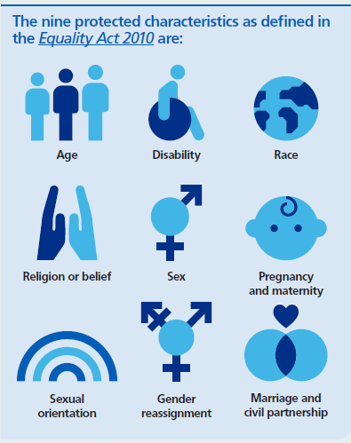

Image reproduced from NHS EDI improvement plan.

Appendix 2: WRES data submission spreadsheet 2023 pdf attached separately

Appendix 3
WRES dashboard: Staff in post profile by band by Trust and by division WRES indicators 5-8 survey
CUH Staff by pay band and ethnicity Trust wide and by division. Data as at 31st March 2023
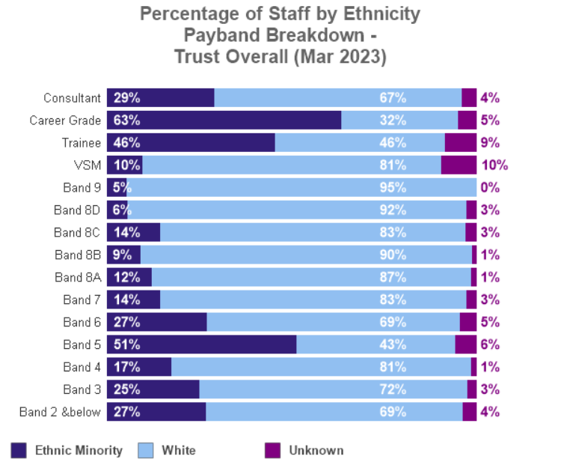

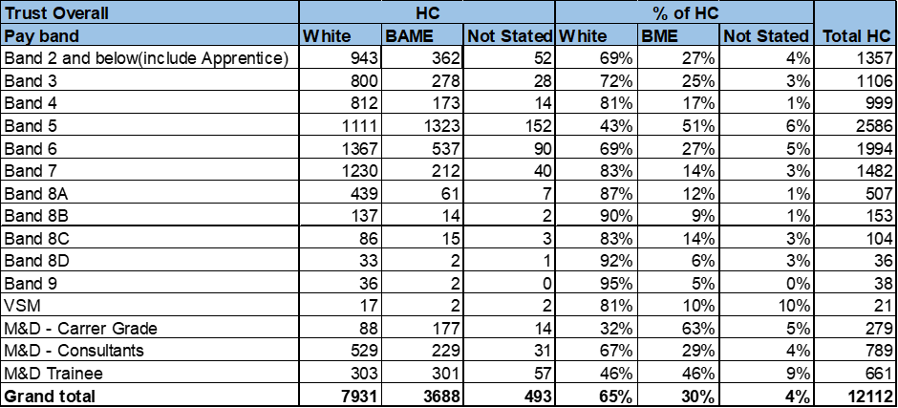
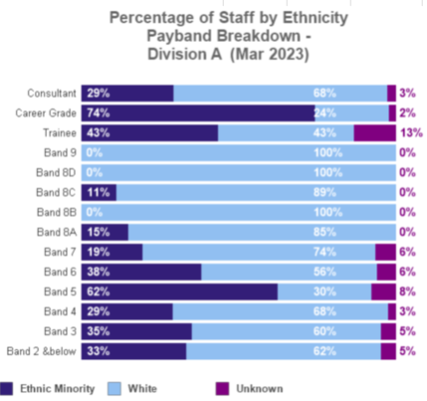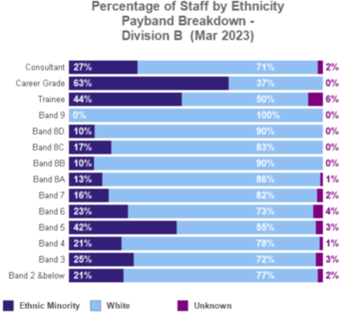

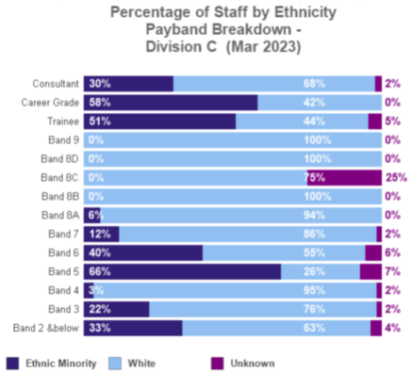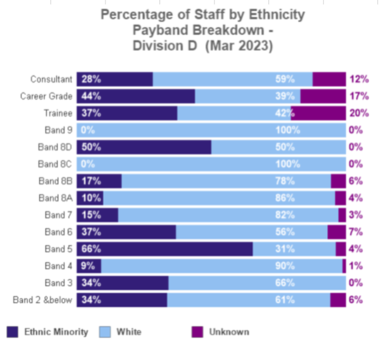

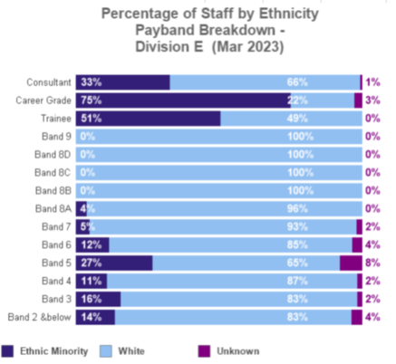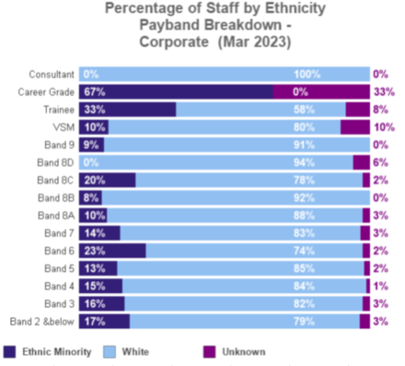
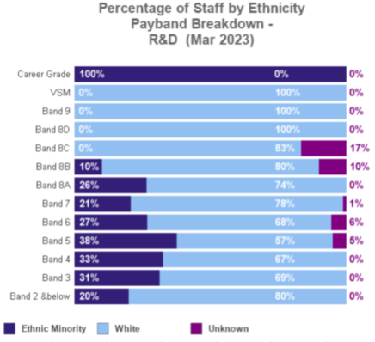

WRES Indicator 5-8 detail by division NSS 2022
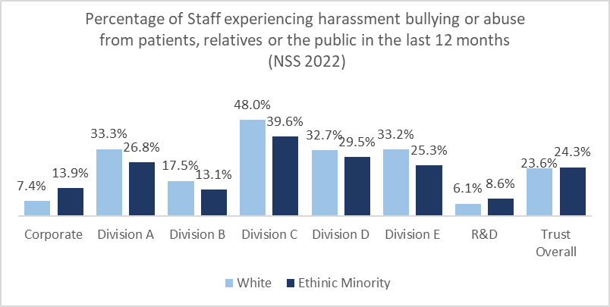

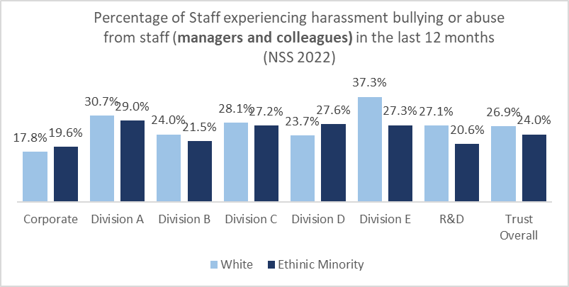

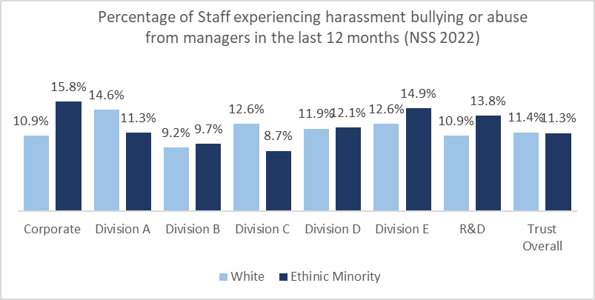

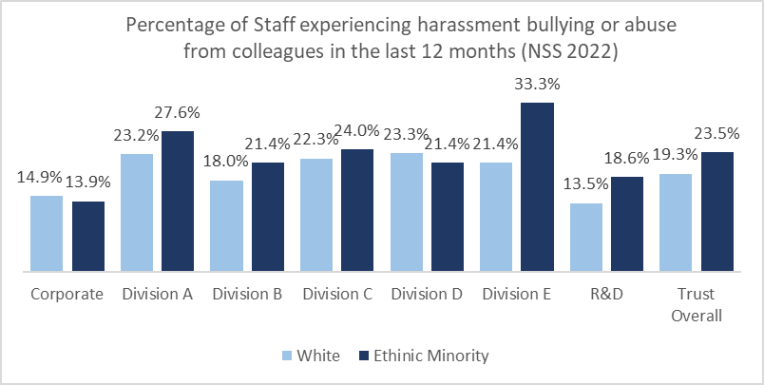

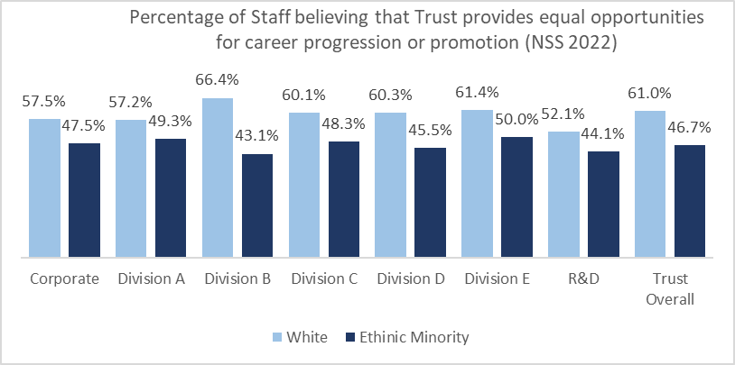

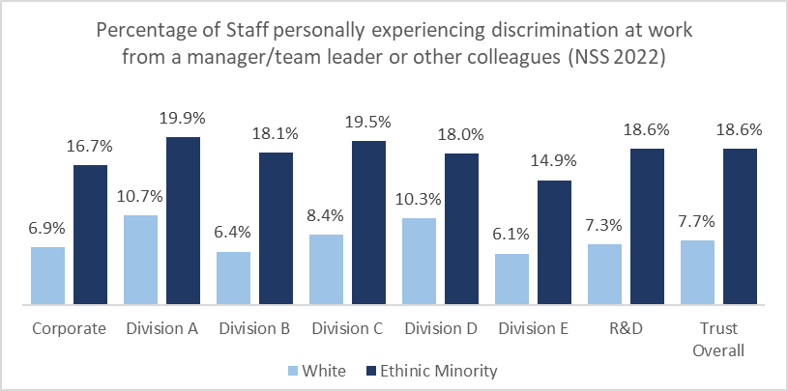

Appendix 4: Unison Anti-racism charter 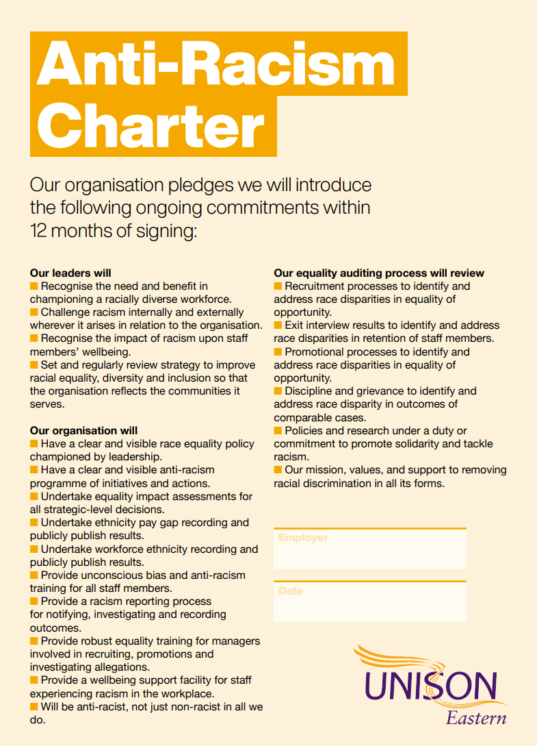

Appendix 5: NHS EDI improvement plan
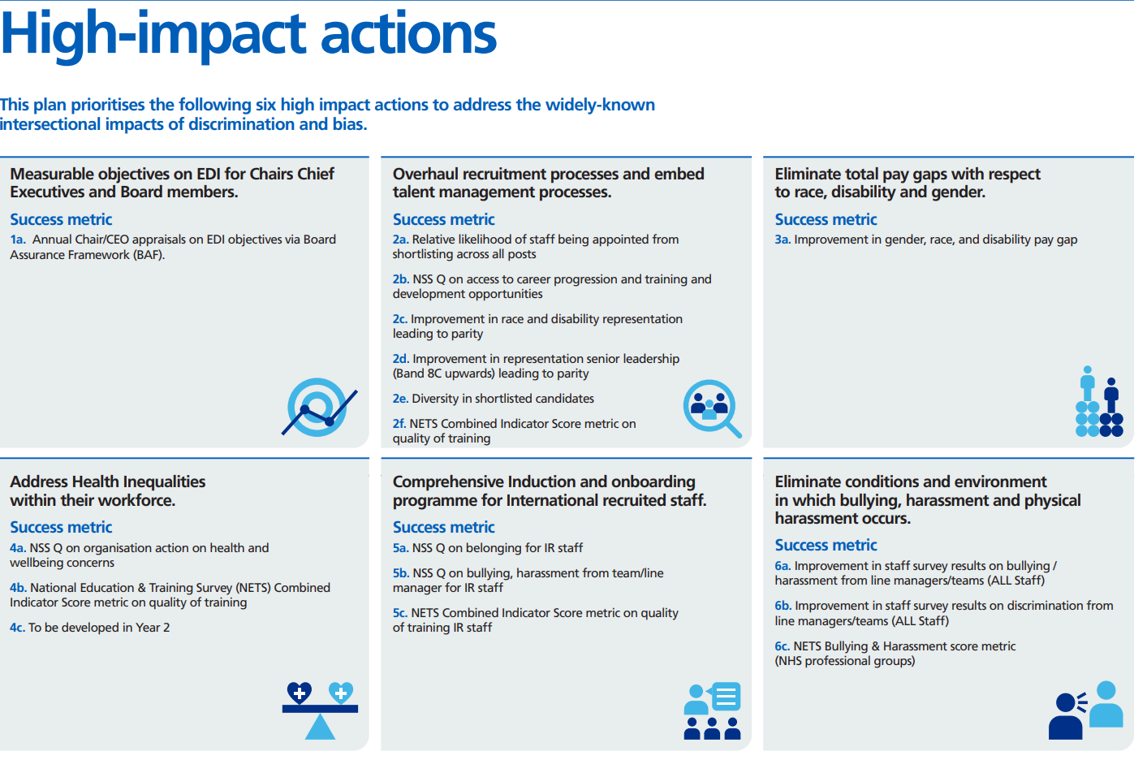

West, M and Dawson, J. NHS Staff Management and Health Service Quality. 2011
Dawson, J. Does the experience of staff working in the NHS link to the patient experience of care? 2009
West, M et al 2012 NHS Staff Management and Health Quality Results from the NHS staff survey and related data
Understanding intersectionality and engaging with diverse staff and communities | NHS Employers

